/



Workforce Connections:  
Workforce Specialist  
Project Framework

March 2022



Creative Commons

With the exception of the Commonwealth Coat of Arms, the Department’s logo, any material protected by a trade mark and where otherwise noted all material presented in this document is provided under a [Creative Commons Attribution 4.0 Australia](https://creativecommons.org/licenses/by/4.0/) licence.  
The details of the relevant licence conditions are available on the Creative Commons website (accessible using the links provided) as is the full legal code for the [CC BY 4.0 AU licence](https://creativecommons.org/licenses/by/4.0/legalcode).

The document must be attributed as the Australian Government Department of Education, Skills and Employment, Workforce Connections: Workforce Specialist Project Framework.

**Contents**

Executive Summary 6

The Workforce Specialist initiative 7

Objective of the Workforce Specialists initiative 7

Workforce Specialists Panel 7

Workforce Specialist projects 8

Workforce Connections: Workforce Specialist Project Framework 10

Purpose and operation of the Framework 10

Evidence and data analysis 11

Stakeholder consultation 11

Industry-specific workforce initiatives 11

Setting the Scene 13

COVID-19 has had a significant impact on the Australian labour market 13

Skill level and workforce diversity varies across industries 17

Job seekers in employment services provide a key source of labour 19

Long-term there will be a range of job opportunities across the economy 21

Approach to identifying industries and occupations in the Framework 24

Data sources and methodology 24

Identifying industries for inclusion in the Workforce Connections: Workforce Specialist Project Framework 25

Accommodation and Food Services 26

Industry snapshot 26

An industry in early recovery 26

Domestic and international tourism to drive demand for workers 27

Flexible hours may suit job seekers, particularly the young, looking for flexible work 28

Agriculture, Forestry and Fishing 30

Industry snapshot 30

The industry has shown resilience during COVID-19 though labour availability remains a challenge 30

A skilled and available workforce is needed to support growth in production 33

The industry provides opportunities for work and career pathways 34

Construction 35

Industry snapshot 35

Industry is recovering, with skill shortages across a range of occupations 35

A wide range of occupations, though most have mandatory entry requirements, and many are physically demanding 36

Most workers are male, but there are efforts to attract and retain more women in the industry 37

Apprenticeships and traineeships are a common entry pathway 38

Health Care and Social Assistance 40

Industry snapshot 40

Strong employment growth projected to continue with growing demand for services across the industry 40

Growing personal care sector will need to attract new workers 43

Early Childhood Education and Care 44

Other supporting roles provide an opportunity to work in the industry 45

Manufacturing 46

Industry snapshot 46

Manufacturing supports and enables other industries across the economy including as part of the COVID-19 response 46

Existing skills shortages in Manufacturing are exacerbated by the pandemic 47

Currently most manufacturing production related workers are male and working in jobs in Skill Level 3 and 4 roles 47

Manufacturing is undergoing a transformation towards advanced, higher-value activities 49

There are employment opportunities in all six National Manufacturing Priorities 50

Retail Trade 51

Industry snapshot 51

Continued growth expected, despite a shift towards online retailing 51

Opportunities for youth and part-time workers 53

Retail provides an opportunity to gain skills and experience and explore career pathways 53

Transport, Postal and Warehousing 56

Industry snapshot 56

A resilient industry adapting to COVID-19 and e-commerce 56

Demand for services will remain strong, supporting employment growth in the industry 57

There are a range of roles that provide opportunities for job seekers 58

Drivers are a key part of this industry 59

Digitisation and automation will continue to change the workforce needs of the sector 60

Emerging Priorities 61

Immediate needs 61

Emerging and significant opportunities 61

Other considerations and future inclusion in the Framework 62

Reviewing the Workforce Connections: Workforce Specialist Project Framework 63

Industry duration in the Framework 63

Appendix A 65

**Table of Figures**

Figure 1: How the Workforce Connections: Workforce Specialist Project Framework shapes the Workforce Specialists initiative 10

Figure 2. Employment (‘000), December 2019 to December 2021 13

Figure 3. The number of jobactive participants surged due to the pandemic 15

Figure 4. The Internet Vacancy Index reflects recruitment activity variance due to COVID-19 restrictions 16

Figure 5. Skill level definitions 17

Figure 6. More than half of jobactive participants do not have post-school qualifications 20

Figure 7. jobactive job placements are unevenly spread across industries 21

Figure 8. Employment level, past and projected 22

Figure 9. Projected employment growth, November 2020 to November 2025, by skill level 23

Figure 10. Job advertisements for hospitality workers were greatly impacted by COVID-19 restrictions 27

Figure 11. Skill Levels 2, 4 & 5 are most common among Accommodation & Food Services workers 29

Figure 12. Older age groups are over-represented in this industry 31

Figure 13. Skill level among Agriculture, Forestry and Fishery workers 32

Figure 14. Most major occupation groups in Construction have a majority of male workers (000’s) 37

Figure 15. Skill Level 3 roles are more common among Construction workers 39

Figure 16. The industry continued to experience strong demand during COVID-19 42

Figure 17. Skill Levels 1 and 4 are most common among Health Care and Social Assistance workers 42

Figure 18. Manufacturing is male-dominated across the majority of occupation types (000’s) 48

Figure 19. Manufacturing roles are broadly dispersed across skill levels 48

Figure 20. Outline of the manufacturing value chain demonstrates range of employment opportunities across the sector 49

Figure 21. Retail Trade employment has been impacted by the pandemic (‘000s) 52

Figure 22. Uneven sector growth is projected over the five years from November 2020 to November 2025 (‘000s) 52

Figure 23. More than half of all Retail Trade workers are Skill Level 5 54

Figure 24. Projected growth across the Transport, Postal and Warehousing industry 57

Figure 25. Skill level of Transport, Postal and Warehousing industry workers 58

Figure 26. Top occupations in the Transport, Postal and Warehousing industry (‘000s) 59

Figure 27. Employment level (‘000), November 2021 65

Figure 28. Projected employment growth (%) November 2020 to November 2025 66

**Table of Tables**

Table 1. The distribution of skill levels varies considerably across industries 18

Table 2. jobactive participants are a diverse group 20

Table 3. Indicative duration of each industry’s inclusion in the Framework 63

# Executive Summary

The Workforce Specialists initiative is a key element of Workforce Australia which will support job seekers prepare for and move into employment and help industry meet its workforce needs.

The *Workforce Connections: Workforce Specialist Project Framework* (the Framework) will guide and inform Workforce Specialist projects.

The Framework identifies industries and occupations with significant labour market opportunities for job seekers, to support the identification, development, approval and delivery of Workforce Specialist projects. All projects will be required to meet the objectives of the Workforce Specialist initiative and represent value for money.

The Workforce Specialist initiative and the Framework contribute to and support the objectives of Workforce Australia, the broader workforce agenda and the COVID-19 recovery.

The COVID-19 pandemic has had a significant impact on the Australian labour market. The Australian economy and the labour market will continue to undergo structural changes including the acceleration of digitisation, the ongoing structural shift in economic activity to the services sector, and the growth in higher skill level jobs. These factors will influence the skills and experience job seekers will need to move into employment both in the short term and over the longer term.

The National Skills Commission projects employment will grow by almost one million between November 2020 to November 2025, across most industries and in both higher and lower skilled roles.[1] The education attainment and job placement data for current participants of mainstream employment services provides an insight into the industries and roles which job seekers may be well positioned to move into with the support of a Workforce Specialist.

There are opportunities for job seekers across all industries in the economy. The purpose of the Framework is to target industries that may have significant opportunities for job seekers and would benefit from a Workforce Specialist project.

The first iteration of this Framework identifies seven industries, as well as the principles for considering emerging priorities in other industries which may also benefit from a Workforce Specialist project. The industries included in the first iteration of the Framework are:

* Accommodation and Food Services
* Agriculture, Forestry and Fishing
* Construction
* Health Care and Social Assistance
* Manufacturing
* Retail Trade
* Transport, Postal and Warehousing
* Emerging Priorities

The Framework will be reviewed annually to respond to changes in the labour market, identify new and emerging opportunities, and to ensure existing industries are still relevant.

# The Workforce Specialist initiative

As part of the 2021–22 Budget, the Australian Government announced a new employment services model to be developed to replace jobactive from July 2022. This model will be known as Workforce Australia.

A key feature of the Workforce Australia employment service is an online service where, job ready job seekers who can self-manage their way back to employment will receive personalised service options to assist them to find a job. Job seekers identified as requiring additional support will be referred to a Workforce Australia Services Provider or Workforce Australia – Transition to Work provider and receive tailored servicing.

A significant element of Workforce Australia is the Workforce Specialists initiative. A panel of Workforce Specialists will be established from July 2022 to deliver a range of strategic projects to meet the workforce needs of identified key industries and occupations, connecting them with suitable job seekers who receive Workforce Australia Services or Workforce Australia – Transition to Work Services. Funding of $12.5 million will be available each financial year to support the delivery of Workforce Specialist projects.

The *Workforce Connections: Workforce Specialist Project Framework* (the Framework) identifies the key industries and occupations with significant labour market opportunities for job seekers to inform delivery of Workforce Specialists projects.

The Framework will be the core guiding document for the Workforce Specialist panel, the Department of Education, Skills and Employment (the department) and other stakeholders to identify, develop, approve and deliver Workforce Specialist projects.

The first iteration of the Framework has been developed by the department in consultation with key stakeholders and will be updated regularly by the department to respond to changes in the labour market. Workforce Specialists may also be used to respond to emerging workforce opportunities or challenges.

## Objective of the Workforce Specialists initiative

The Workforce Specialists initiative aims to:

* connect job seekers to labour market opportunities in identified industries and occupations, providing a sustainable pathway to support job seekers to gain or build on the skills and attributes needed to take up these opportunities
* provide project-based solutions to meet the workforce needs of industries identified in the *Workforce Connections: Workforce Specialist Project Framework* or other emerging needs as identified by the department, and
* provide project-based solutions across a broad geographical or industry/occupation focus, leveraging existing initiatives at the national and state and territory government level.

## Workforce Specialists Panel

The Workforce Specialists panel will commence July 2022 following the outcomes of a Request for Proposal. Panel members will be engaged on an as-needed basis (see project approval process below) to provide tailored workforce solutions for identified industries and occupations to respond to labour market opportunities for job seekers. Workforce Specialists will work collaboratively with other employment services providers, the department and other relevant stakeholders to deliver Workforce Specialist projects.

## Workforce Specialist projects

Workforce Specialist projects will actively target identified industries and occupations with significant labour market opportunities for job seekers receiving Workforce Australia Services or Workforce Australia – Transition to Work Services.

Projects will assist identified industries to meet their workforce needs and connect businesses to suitable job seekers. Projects may also support job seekers to identify, access and engage with:

* labour market opportunities within these industries
* the skills and training pathways to connect with these opportunities
* potential areas for career progression, and/or
* the support available to prepare for and take up these employment opportunities.

The design of projects delivered by Workforce Specialists will be informed and guided by this Framework, align with the objectives of the Workforce Specialists initiative, and represent value for money under the initiative (refer to Project approval process below).

Projects will vary in size and duration, for instance one project may operate for six months, whereas another may have multiple stages and operate for three years. One or more Workforce Specialists could be engaged on any one project.

Projects could potentially include increasing awareness of opportunities within an industry, improving job readiness, creating industry specific pre-employment pathways including targeted training, assessment centres and induction training to support large scale recruitment, opportunities to gain work experience, and providing post-placement support and mentoring to job seekers starting a new job.

### Supporting workforce diversity

Projects may also provide an opportunity to support greater workforce diversity within an industry. For example, projects could focus on improving gender diversity by supporting men to take up roles in the Health Care and Social Assistance industry, or women to take up roles in Construction. Projects could aim to attract a broader age demographic to an industry by supporting young people or mature age workers into employment.

There is also an opportunity to increase employment outcomes for Aboriginal and Torres Strait Islander peoples to contribute to Closing the Gap targets under the *National Agreement on Closing the Gap*.[2] This includes assistance to connect with skills and training pathways, pre-employment support and employment within identified industries.

Projects may also support an increase in the number of people with disability in secure employment contributing to the objectives of *Employ My Ability* – the Disability Employment Strategy[3].

### Complementing and leveraging other initiatives

Projects will complement other services and, where possible, will leverage existing programs and initiatives in design and operation. This includes (but is not limited to) Workforce Australia Services, Workforce Australia – Transition to Work, the Local Jobs Program, the Launch into Work Program, Employer Liaison Officers, complementary employment services programs (such as Youth Jobs PaTH, the National Work Experience Program and Harvest Trail Services) and other initiatives, including Industry Clusters in the vocational education and training (VET) system, the National Careers Institute and those funded by state and territory governments. Workforce Specialist projects will generally support responses to workforce needs that are not delivered by other existing programs and/or where additional capacity is required.

### Project approval process

As part of the project approval process, the department will consider whether the project concept aligns with the objectives of the Workforce Specialist initiative. This will include consideration of whether the workforce need should be met through another program or through the ordinary functioning of the labour market. Projects must also meet the following core project criteria:

1. the project responds to industry or occupation priorities identified in the *Workforce Connections: Workforce Specialist Project Framework* or other emerging priorities as assessed by the department
2. the project clearly connects job seekers with employment opportunities and/or will assist job seekers to improve their employability skills
3. the project provides value for money, and
4. the project can be delivered according to the proposed timeframe and within the scope and budget of the Workforce Specialists initiative.

The project approval process will include an initial assessment of the project concept and, where appropriate, discussions with one or more Workforce Specialists. Project concepts may progress to a co-design stage where the Workforce Specialist/s and the department will further refine the project concept prior to final approval. Other stakeholders may also be engaged during co-design, particularly employers or training providers involved in the delivery of the proposed project.

**Key Points**

* The Workforce Specialists initiative will commence 1 July 2022, with funding of $12.5 million available each financial year for Workforce Specialist projects.
* Workforce Specialist projects will help meet the workforce needs of identified industries and occupations, connecting them to suitable job seekers.
* This Framework will guide and inform the development, approval and delivery of Workforce Specialist projects.
* Projects may support job seekers to identify employment opportunities, identify/access skills, training, career pathways and/or prepare for and take up employment.
* Projects will complement and leverage other existing programs, where possible.
* There is an opportunity to support greater workforce diversity and employment of job seekers, for example people with disability, Aboriginal and Torres Strait Islander peoples, youth and women, across the industries identified in this Framework.

# Workforce Connections: Workforce Specialist Project Framework

## Purpose and operation of the Framework

The *Workforce Connections: Workforce Specialist Project Framework* identifies industries and occupations with significant labour market opportunities for job seekers for targeted investment as part of the Workforce Specialist initiative.

The Framework’s objective is to inform and guide the delivery of projects by Workforce Specialists.

The Framework has been developed by the department in consultation with various stakeholders including industry, employers, government agencies and the National Skills Commission. The Framework is designed to support and complement industry-specific workforce strategies and plans.

Each priority industry under the Framework will have its own implementation plan, to support the design and delivery of projects in both the short and long-term.

The Framework will be reviewed regularly to respond to changes in the labour market. Workforce Specialists may also be used to respond to emerging workforce opportunities or challenges.

The department provides no guarantee of the number or value of projects for each industry identified in this Framework. Each project concept will be considered in line the project approval process outlined above, of which the Framework is one element.

Figure 1: How the Workforce Connections: Workforce Specialist Project Framework shapes the Workforce Specialists initiative

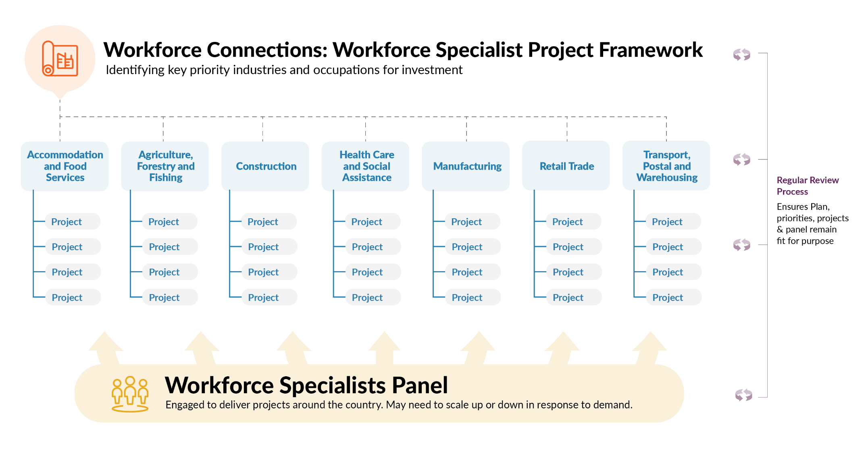

## Evidence and data analysis

To inform the development of the Framework, the department has reviewed a range of information sources to support the identification of industries for inclusion in the first iteration of the Framework. This information has been drawn from stakeholder consultation and industry specific strategies/plans (outlined below), as well as data and evidence from the National Skills Commission, the Australia Bureau of Statistics, industry-specific bodies such as Industry Reference Committees and the Australian Bureau of Agricultural and Resource Economics and Sciences, and other relevant organisations.

The department has also considered information about the job seekers who may participate in a Workforce Specialist project, including demographic data, educational attainment, and the industries where job seekers commonly find employment.

The focus of this analysis was to identify those industries with significant labour market opportunities for job seekers, particularly those with workforce needs most likely to benefit from Workforce Specialist projects. That is, interventions at a large scale, across multiple locations, to support job seekers to connect with the opportunities in the industry.

Refer to the *Approach to identifying industries and occupations* section for further detail on how this information has been used in the development of the Framework.

## Stakeholder consultation

The department undertook stakeholder consultation in the second half of 2021 to inform the development of the first iteration of the Framework. A range of stakeholders were consulted, including:

* industry associations, business councils and other representative bodies
* employment services providers and their representatives
* Commonwealth, state and territory government agencies, including the   
  National Skills Commission
* the Employment Services Advisory Group. [4]

Stakeholder consultation included stakeholder meetings, online webinars and a feedback survey. Recordings of the webinars, including the presentation and transcript, are available on the department’s website. [5]

Further stakeholder consultation will occur as the Framework is regularly reviewed in the future. Refer to the *Reviewing the Workforce Connections: Workforce Specialist Project Framework* section for further information.

## Industry-specific workforce initiatives

There are also a number of existing industry-specific workforce strategies and plans that will be drawn on when developing Workforce Specialist projects and have been reviewed in the development of this Framework. These strategies and plans provide an understanding of the workforce needs of specific industries, including the opportunities, challenges and areas for action.

The insights in these strategies, alongside the stakeholder consultation outlined above, were used to demonstrate opportunities where workforce needs could be met through connection to suitable job seekers supported by a Workforce Specialist project.

These industry-specific strategies, in addition to the Framework, will also inform the development and delivery of Workforce Specialists projects.

**Key Points**

* The *Workforce Connections: Workforce Specialists Project Framework* identifies the key industries and occupations with labour market opportunities for job seekers for targeted investment as part of the Workforce Specialist initiative.
* This Framework will guide and inform the development, approval and delivery of Workforce Specialist projects.
* The development of the Framework has been informed by a range of data analysis, evidence and stakeholder consultation.
* The Framework complements industry-specific workforce strategies, identifying where Workforce Specialist projects may assist to meet industry workforce needs through connection to suitable job seekers.

# Setting the Scene

## COVID-19 has had a significant impact on the Australian labour market

The Australian labour market had been performing well up until the onset of the COVID-19 pandemic, with employment increasing by 219,800 (or 1.7 per cent) over the year to March 2020 (when Australia recorded its 100th case of COVID-19), just under the decade average annual growth rate of 1.8 per cent at the time.

The pandemic initially had a significant, negative impact on the Australian labour market, with employment falling much more quickly and dramatically than in any previous recession, which was also accompanied by many people leaving the labour force between March 2020 and May 2020. That said, the Australian labour market rebounded strongly between May 2020 and June 2021, as a result of the effective elimination of coronavirus cases and an easing of restrictions in most jurisdictions, at the time.

Figure 2. Employment (‘000), December 2019 to December 2021

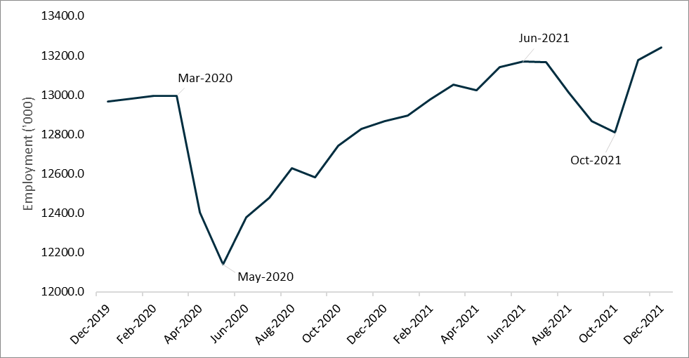

**Source**: Australian Bureau of Statistics, Labour Force, Australia*,* December 2021, seasonally adjusted data.

Reflecting the outbreak of the Delta variant across a number of jurisdictions and the associated lockdowns, employment decreased by 359,500 (or 2.7 per cent) between June 2021 and October 2021. While the unemployment rate only rose by 0.3 percentage points between June 2021 and October 2021, to 5.2 per cent, a large number of people (333,100) left the labour force over that period, which pushed the participation rate down, by 1.6 percentage points, to stand at 64.6 per cent in October 2021.[6]

The Australian labour market rebounded strongly following the end of the Delta lockdowns, with employment increasing by 430,900 (or 3.4 per cent) between October 2021 and December 2021, to a record high of 13,242,000. Employment is now 246,600 (or 1.9 per cent) above the level recorded in March 2020.

Against the backdrop of a significant recovery in employment, the unemployment rate fell sharply from 5.2 per cent in October 2021, to 4.2 per cent in December 2021, the lowest rate recorded since August 2008 and well below the 5.3 per cent recorded in March 2020. Importantly, in the two months to December 2021, high vaccination rates and the easing of restrictions encouraged 299,300 people to enter the labour market over the period. This pushed the participation rate up, by 1.4 percentage points, to 66.1 per cent in December 2021, above the 65.9 per cent recorded in March 2020.

While labour market activity in Australia rebounded strongly in late 2021, future outbreaks and associated health restrictions may continue to lead to some uncertainty in the labour market – at least in the short-term.

Young people (15–24 years) have been particularly hard-hit by the pandemic, as they are often casual workers and are also overrepresented in industries that have been most severely affected by the impact of COVID-19. For instance, youth employment fell by 155,800 (or 8.0 per cent) between June 2021 and October 2021. Labour market conditions for youth have improved considerably in the two months to December 2021, in line with the rebound in overall labour market activity following the end of the Delta lockdowns. Youth employment rose by 160,600 (or 9.0 per cent) between October 2021 and December 2021 and is now 6,900 (or 0.4 per cent) above the level recorded in March 2020.[7]

Women have also been negatively affected by COVID-19, as they are also more likely to be employed in the forward-facing industries most affected by lockdowns, and because they are more likely to reduce their working hours to take on caring responsibilities, particularly during periods accompanied by school closures. Female employment decreased by 216,900 (or 3.5 per cent) between June 2021 and October 2021, compared with a fall of 142,600 (or 2.0 per cent) in male employment over the same period.

Labour market conditions for women have improved considerably following the end of the Delta lockdowns. Female employment increased by 237,800 (or 3.9 per cent) between October 2021 and December 2021, to be 122,800 (or 2.0 per cent) above the level recorded in March 2020. Male employment also rose over the same period, by 193,200 (or 2.9 per cent), and is now 123,800 (or 1.8 per cent) above the level recorded in March 2020.[8]

The number of Australians seeking Government assistance has also increased during the pandemic, with the number of jobactive participants increasing sharply at the start of the pandemic, before beginning to fall over the last 12 months – see *Figure 3*.[9] To date, subsequent outbreaks have not resulted in the same sharp rise in jobactive participants as seen in March 2020. This is likely due to many workers adversely affected by COVID-19 public health orders receiving the COVID-19 Disaster Payment in the short-term rather than an income support payment with connection to employment services.

Figure 3. The number of jobactive participants surged due to the pandemic

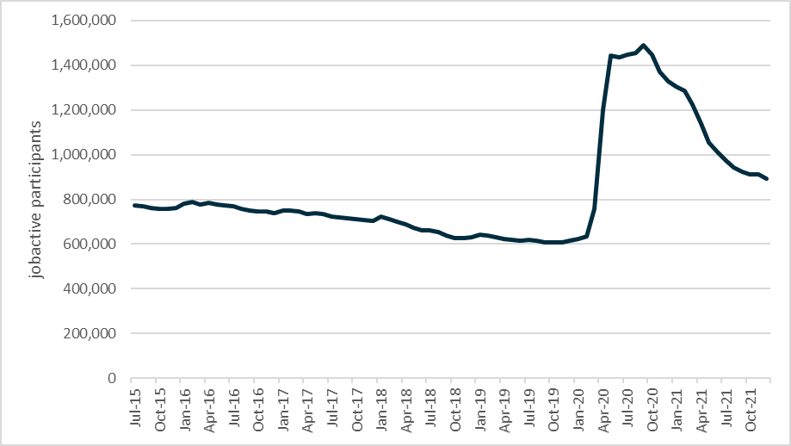

**Source**: Department of Education, Skills and Employment, jobactive administrative data, December 2021.

Job vacancies have also been impacted by the COVID-19 pandemic – see *Figure 4*. The Internet Vacancy Index fell significantly at the start of the COVID-19 outbreak, before recovering to above pre-COVID-19 levels. Following the COVID-19 Delta outbreak, recruitment activity fell for three consecutive months to August 2021 by 9 per cent. Job advertisements increased in the three consecutive months to November 2021 by 14.8 per cent as employers recommenced hiring to support the reopening of many jurisdictions, including reengaging workers separated from employment during the pandemic, before declining by 2.5 per cent in December 2021.[10]

Notably, the level of recruitment activity nationally remains significantly elevated compared to pre-COVID-19 levels, an increase of 46 per cent.[11] Compared to pre-COVID-19 levels, recruitment activity is also elevated across all skill level groups. These figures indicate there are increasing opportunities for job seekers to move into or be reengaged in employment.

Figure 4. The Internet Vacancy Index reflects recruitment activity variance due to COVID-19 restrictions

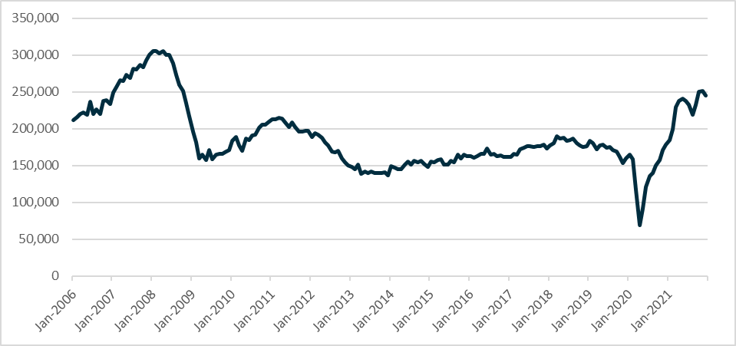

**Source**: National Skills Commission, *Internet Vacancy Index*, seasonally adjusted, December 2021.  
N.B. The Internet Vacancy Index does not reflect the total number of job advertisements in the labour market, rather, it is based on a count of online job advertisements newly lodged on SEEK, CareerOne and Australian JobSearch during the month.

The international border closure has also reduced the size of the potential labour force in the short to medium term due to a reduction in temporary visa holders with working rights in Australia, particularly for those industries that have a higher dependence on non-employer-sponsored international workers.[12] This includes the agriculture and hospitality sectors, with many roles available that may be suitable for job seekers in employment services.

The Australian economy and the labour market will continue to undergo structural changes that in some instances may have been accelerated as a result of the COVID-19 pandemic.[13] This includes the acceleration of digitisation, the ongoing structural shift in economic activity to the services sector[14], and the growth in higher skill level jobs. These changes have implications for job seekers looking for work, particularly in relation to the jobs available and skills in demand from business and industry. This will influence the training and pre-employment pathways that may support a job seeker to move into work, including through Workforce Specialist projects.

## Skill level and workforce diversity varies across industries

The skill level required for roles across industries varies, with some industries having roles concentrated at one skill level and others with roles more evenly spread across two or three skill levels. For example, roles in the Accommodation and Food Services industry are generally found across Skill Level 2 (Advanced Diploma or Diploma), Skill Level 4 (Certificate II or III) and Skill Level 5 (Certificate I or Year 12 and below), whereas roles in the Professional, Scientific and Technical Services are concentrated at Skill Level 1 (Bachelor degree or higher qualification).

Figure 5. Skill level definitions

#### What is a Skill Level?

As part of the Australian New Zealand Standard Classification of Occupations (ANZSCO), skill level is defined as a function of the range and complexity of the set of tasks performed in a particular occupation. The greater the range and complexity of the set of tasks, the greater the skill level of an occupation.

**Skill Level 1** is equivalent to a Bachelor’s Degree or higher qualification

**Skill Level 2** is equivalent to an Advanced Diploma or Diploma

**Skill Level 3** is equivalent to a Certificate IV or Certificate III (incl. 2 years on-the-job training)

**Skill Level 4** is equivalent to a Certificate II or III

**Skill Level 5** is equivalent to a Certificate I or secondary education

The skill level across industries provides an overview of the skills and experience required to take up various roles within an industry (see *Table 1*). Combined with the job seeker educational attainment data in the following section, this information provides an insight into industries with significant labour market opportunities for job seekers.

Table 1. The distribution of skill levels varies considerably across industries

|  |  |  |  |  |  |
| --- | --- | --- | --- | --- | --- |
| Industry | Skill level | | | | |
| 1 | 2 | 3 | 4 | 5 |
| Agriculture, Forestry and Fishing | 57.0% | 2.9% | 5.8% | 12.1% | 22.2% |
| Mining | 27.2% | 11.3% | 19.8% | 37.3% | 4.3% |
| Manufacturing | 24.4% | 7.2% | 25.1% | 24.3% | 18.9% |
| Electricity, Gas, Water and Waste Services | 34.8% | 12.3% | 17.8% | 26.1% | 9.0% |
| Construction | 16.5% | 8.7% | 45.4% | 17.3% | 12.2% |
| Wholesale Trade | 30.1% | 8.9% | 9.6% | 38.2% | 13.1% |
| Retail Trade | 9.2% | 14.1% | 5.7% | 20.2% | 50.8% |
| Accommodation and Food Services | 3.1% | 26.7% | 4.8% | 27.6% | 37.8% |
| Transport, Postal and Warehousing | 11.7% | 5.6% | 5.7% | 63.1% | 13.8% |
| Information Media and Telecommunications | 57.0% | 11.3% | 14.0% | 11.3% | 6.4% |
| Financial and Insurance Services | 46.3% | 15.7% | 20.9% | 16.7% | 0.5% |
| Rental, Hiring and Real Estate Services | 18.0% | 13.4% | 44.4% | 17.8% | 6.5% |
| Professional, Scientific and Technical Services | 67.9% | 14.8% | 7.2% | 8.2% | 1.8% |
| Administrative and Support Services | 17.5% | 9.7% | 16.7% | 16.3% | 39.7% |
| Public Administration and Safety | 35.9% | 22.4% | 5.3% | 31.3% | 5.2% |
| Education and Training | 67.3% | 5.2% | 5.3% | 19.7% | 2.5% |
| Health Care and Social Assistance | 47.5% | 12.1% | 6.8% | 29.3% | 4.4% |
| Arts and Recreation Services | 30.1% | 13.0% | 15.4% | 28.5% | 12.9% |
| Other Services | 11.4% | 10.8% | 52.8% | 17.1% | 7.8% |
| **ALL INDUSTRIES** | **33.5%** | **12.3%** | **15.1%** | **24.1%** | **15.1%** |

**Source**: Australian Bureau of Statistics, Labour Force Estimates, Customised Table - Employed Persons, by Industry Division of Main/Last Job, by Occupation of Main/Last Job, 2020, provided by the National Skills Commission.  
N.B. Shaded cells indicate the figure is at least five percentage points higher than the average for all industries.   
Rows may not sum to 100% due to rounding.

Australia, like many countries, has a gender imbalance across many industries, i.e. a workforce that is predominantly of one gender. The following industries have the highest proportions of male or female workers[15]:

* **Construction**  
  (87 per cent male)
* **Mining**  
  (81 per cent male)
* **Transport, Postal and Warehousing**   
  (78 per cent male)
* **Health Care and Social Assistance**  
  (76 per cent female)
* **Education and Training**  
  (71 per cent female)
* **Accommodation and Food Services**  
  (55 per cent female)

The age distribution of workers across Australia’s industries also varies widely. The following industries have the highest proportions of youth (under 25 years) or mature age workers (55 years and over)[16]:

* **Accommodation and Food Services**   
  (49 per cent youth)
* **Retail Trade**   
  (30 per cent youth)
* **Arts and Recreation**   
  (25 per cent youth)
* **Agriculture, Forestry and Fishing**   
  (43 per cent mature age)
* **Rental, Hiring and Real Estate Services** (28 per cent mature age)
* **Electricity, Gas, Water and Waste Services** (27 per cent mature age)

Across the identified industries in this Framework, there is an opportunity to increase workforce diversity through Workforce Specialist projects. This could include increasing the gender and age diversity of the workforce as well as increasing participation of other groups of job seekers. For example, there is an opportunity to increase the workforce participation of people with disability, people from a culturally and linguistically diverse background and refugees with appropriate support through a Workforce Specialist project. There is also an opportunity to increase the proportion of Aboriginal and Torres Strait Islander peoples who are employed to contribute to Closing the Gap targets under the *National Agreement on Closing the Gap*.

## Job seekers in employment services provide a key source of labour

As outlined in the *Introduction* to this Framework, Workforce Australia Services will replace jobactive from July 2022. Participants in Workforce Specialist projects will be job seekers in Workforce Australia. Therefore, a strong understanding of these job seekers is critical to assist with the identification of industries and occupations with labour market opportunities to target as part of the Workforce Specialist initiative.

As at 31 December 2021, there were over 894,500 job seekers in jobactive. As outlined in *Figure 3*, the number of jobactive participants continues to decline and at the end of January 2022 there were just over 879,000 job seekers in jobactive. *Table 2* and *Figure 6* highlight the characteristics and skill level of these job seekers. This provides an insight into the type of roles they may be able to move into quickly, and the type of support or pathways that could be provided by a Workforce Specialist project to assist the job seekers to prepare for and take up employment.

As outlined, Workforce Specialist projects may also focus on increasing workforce diversity within industries. Workforce diversity has many benefits including job seekers being engaged in sustainable employment and improvements to business service delivery and productivity.[17]

**Table 2. jobactive participants are a diverse group**

|  |  |
| --- | --- |
| Mature Age (55 years and over) | 21.1% |
| Ex-Offenders | 11.2% |
| Aboriginal and Torres Strait Islander peoples | 10.8% |
| Youth (under 25 years) | 15.8% |
| Culturally and Linguistically Diverse | 20.4% |
| People with Disability | 27.7% |

**Source**: Department of Education, Skills and Employment, jobactive administrative data, December 2021.

N.B. A job seeker may belong to more than one cohort e.g., a mature age job seeker with disability.

Between 1 July 2015 and 31 December 2021, there were over 2.2 million job placements for job seekers in jobactive. *Figure 7* provides an insight into the industries where the most job placements have been recorded. These include Accommodation & Food Services, Retail Trade, Construction, and Health Care and Social Assistance. A key theme is that these industries have a range of entry-level to medium skill level roles.

Figure 6. More than half of jobactive participants do not have post-school qualifications

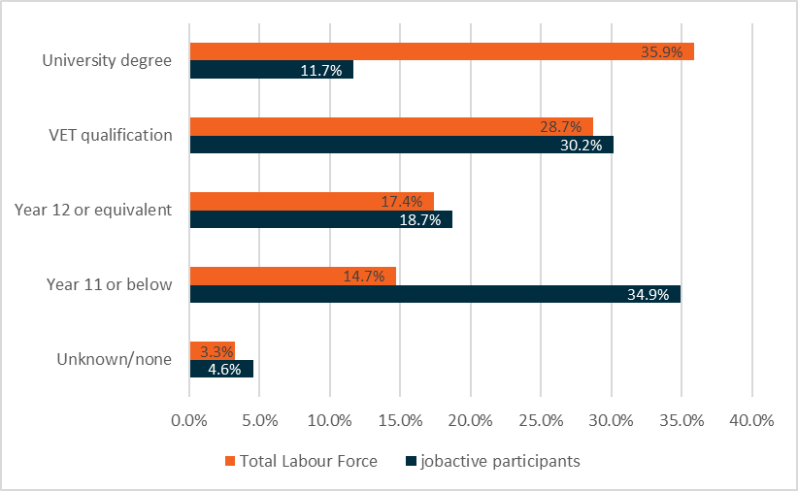

**Sources**: Department of Education, Skills and Employment, jobactive administrative data, December 2021.

Australian Bureau of Statistics, Labour Force, Australia, Detailed, Quarterly, November 2021, original data.

Figure 7. jobactive job placements are unevenly spread across industries

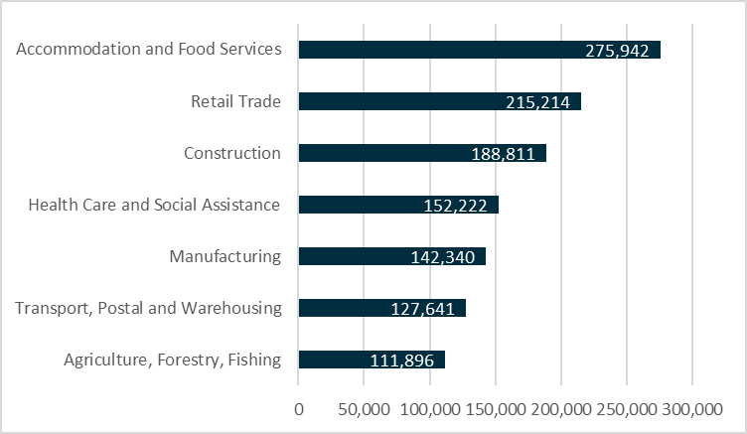

**Source***:* Department of Education, Skills and Employment, jobactive administrative data, July 2015 to December 2021.  
N.B. Does not include ‘Other Services’ or industries with lower placement numbers. ‘Other Services’ industry is often used by many employment services provider staff as a ‘default’ category when entering data into the IT system, not because the job placement is necessarily in that industry.

This information suggests that targeting Workforce Specialist projects to assist job seekers to connect with entry-level roles or those that require a Vocational Education and Training (VET) qualification (Skill Levels 3 to 5) will help maximise employment opportunities for job seekers participating in Workforce Specialist projects.

## Long-term there will be a range of job opportunities across the economy

From November 2020 to November 2025, employment is projected to increase by 991,600 (or 7.8 per cent) with growth across most industries in both highly skilled and lower skilled roles.[18] Noting that with any projections, these are subject to an inherent degree of uncertainty which has been exacerbated by the COVID‑19 crisis, the projections provide an insight into the likely trajectory of employment across industries and occupations.

Figure 8. Employment level, past and projected

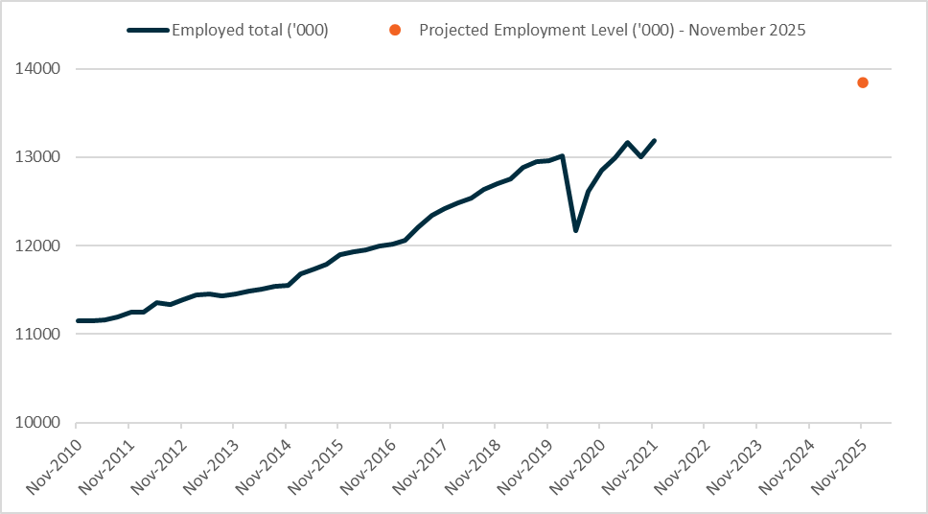

**Source**: Australian Bureau of Statistics, Labour Force, Detailed, Quarterly, seasonally adjusted, November 2021 and NSC, Employment Projections, Five years to November 2025.

### Labour market by industry and skill level

The 2020 employment projections for the five years to November 2025 project employment growth in 17 of the 19 industries (refer to *Appendix A*).[19] The long-term structural shift in employment towards services industries is projected to continue. Three-fifths (or 64.4 per cent) of the total projected employment growth is expected to come from four service-based industries: Health Care and Social Assistance, Accommodation and Food Services, Professional, Scientific and Technical Services, and Education and Training.

Industry specific employment projections for industries identified in this Framework are outlined in more detail in the relevant section. Information on employment levels and projected employment growth from November 2020 to November 2025 for all industries is provided at *Appendix A*.

Employment growth is expected to be concentrated at Skill Level 1 (Bachelor degree or higher qualification) and Skill Level 4 (Certificate II or III) (see *Figure 9*). As outlined above, Skill Level 4 roles are more likely to provide opportunities for job seekers as part of Workforce Specialist projects.

The projections capture forecast net growth and it is noted that industries will continue to experience staff turnover across this period, which may also present opportunities, particularly in entry-level roles, for job seekers to gain skills and experience as existing workers take up other roles.

Figure 9. Projected employment growth, November 2020 to November 2025, by skill level

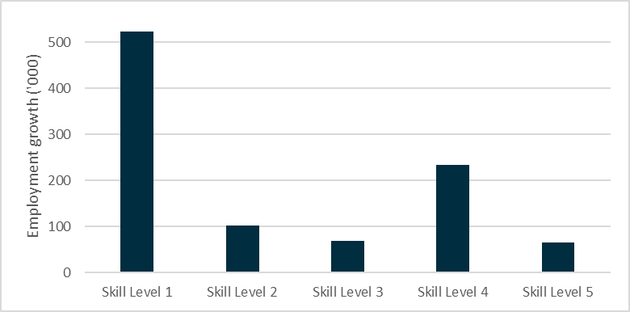

**Source:** National Skills Commission, Skill level projections, Five years to November 2025.

### Industry Clusters will provide a key source of intelligence on workforce issues

Industry Clusters are being established to lead the performance of the national VET system to meet the evolving skills and training needs of industry and employers. The Government will provide an [additional $149.2 million funding over four years](https://www.dese.gov.au/about-us/corporate-reporting/budget/budget-202122#toc-skills-and-training)bringing the total investment to $292.5 million to support these new industry engagement arrangements. The new Industry Clusters will replace the current industry engagement arrangements which includes the 67 Industry Reference Committees and six Skills Service Organisations.

The Industry Clusters, once established in the second half of 2022, will have a role to strategically address workforce challenges by identifying, forecasting and responding to current and emerging skills needs across a range of educational pathways, including VET and higher education. Industry Clusters will also be responsible for developing training products, ensuring training delivery meets employer and learner needs and mapping and promoting career pathways for the industries within their remit. The clusters will become a key source of intelligence and advice on workforce issues that will inform the Framework as well as Workforce Specialists projects in the future.

**Key Points**

* The labour market was significantly affected by the restrictions in place to respond to the COVID-19 pandemic and the subsequent Delta outbreak.
* The economy and labour market are recovering, noting there continues to be uncertainty, including as a result of the Omicron variant.
* Employment across industries varies by skill level. Structural change across the economy will also influence the skills and experience job seekers need.
* Workforce Specialist projects will generally be targeted at assisting job seekers connect with entry-level roles, or roles with training pathways, at Skill Level 3‑5.
* Workforce Specialist projects may support greater workforce diversity particularly among job seeker groups over-represented in employment services.
* Employment is projected to grow from November 2020 to November 2025 in the majority of industries, including many opportunities job seekers can assist to fill.
* The new Industry Clusters will provide a key source of workforce intelligence.

# Approach to identifying industries and occupations in the Framework

## Data sources and methodology

The purpose of this Framework is to identify industries and occupations with workforce needs and significant labour market opportunities for job seekers.

To identify these industries and occupations, a range of quantitative and qualitative information has been used. Key information sources include:

* Total employed persons by industry and occupation[20]
* Projected employment growth by industry and occupation[21]
* Historic employment growth by industry and occupation[22]
* Percentage of roles at Skill Levels 3, 4 and 5 by industry[23]
* Recruitment Insights Report – Recruitment Experiences and Outlook Survey[24]
* Internet Vacancy Index[25]
* Skills Priority List[26]
* Industry specific strategies and plans, including priority areas and actions
* Industry specific reports and analysis
* Stakeholder consultation
* Government policy priorities
* jobactive participant demographics, including educational attainment
* jobactive job placement and outcomes by industry.

The data and analysis from the Australian Bureau of Statistics (ABS) and the National Skills Commission (NSC) provides a consistent measure across all industries when considering the relative size of an industry, current demand for workers, projected future growth, and the types of roles by skill level available now and projected to be in demand in the future.

Industry specific strategies, plans, reports and data, as well as stakeholder consultation, provide a greater understanding of specific industry workforce needs. Likewise, employment services administrative data provides information on the characteristics of job seekers, their education profile, and job placements by industries including the sustainability of these placements.

Placement sustainability indicates positive job seeker outcomes and was considered both in relation to those industries that had sustainable placements, but also those industries where placements were considerably less sustainable, indicating the potential need for additional support.

Industries and occupations that reflect government policy priorities, including where there is significant government investment and/or ongoing labour market challenges (such as the care and support sector and agriculture) have also been considered, particularly in relation to industry specific initiatives and strategies that identify workforce needs including those that could be met by job seekers.

## Identifying industries for inclusion in the Workforce Connections: Workforce Specialist Project Framework

Every industry has its own unique opportunities, challenges and workforce needs – with these factors also differing within each industry and across geographical areas.

As outlined above, a broad range of data and information has informed the development of the Framework. This combination of factors has been used to apply a job seeker lens to industry and occupational labour market analysis. These factors have not been weighted, rather they provided insights to assist with the development of the Framework.

Inclusion in this Framework indicates the industry has significant labour market opportunities for job seekers that could benefit from a Workforce Specialist project. These projects will be designed to connect job seekers with these opportunities, be delivered on a large-scale (such as industry wide or national) and complement and draw together other initiatives and employment services programs.

There is no one factor that has determined whether an industry is included in the Framework. For example, some of the industries in the Framework have high projected future growth, including in occupations that align with the education profile of job seekers. Others may traditionally have high turnover and provide entry-level opportunities for job seekers to gain valuable work experience. Other industries may provide additional opportunities for job seekers that have arisen to support the COVID-19 recovery.

The department acknowledges there will be emerging priorities and challenges outside of the identified industries that may benefit from a Workforce Specialist project. The Framework provides flexibility to consider undertaking projects to address these emerging priorities where the potential project aligns with the intent of the Workforce Specialists initiative, including where there are significant labour market opportunities for job seekers. Refer to the *Emerging Priorities* section for further information.

**Key Points**

* A range of quantitative and qualitative information has been considered through applying both a job seeker and workforce perspective to support the identification of industries and occupations for inclusion in this Framework.
* Every industry has its own unique opportunities, challenges and workforce needs.
* Inclusion in this Framework indicates the industry has significant labour market opportunities for job seekers that could benefit from a Workforce Specialist project.
* Emerging priorities and challenges may also be supported where required.

# Accommodation and Food Services

|  |
| --- |
| Industry snapshot The Accommodation and Food Services industry includes the provision of short-term accommodation, food and beverages, and hospitality services. Examples include hotels, serviced apartments, cafés, restaurants, takeaway food vendors, pubs, and nightclubs.  The industry employs around 6.4 per cent of Australian workers.[27] The highest employing occupations[28] in the industry are:   * Waitstaff * Kitchenhands * Bar Attendants and Baristas.   The industry has been hit hard by COVID-19, but future jobs growth is projected to be very strong  (16.8 per cent between November 2020 to November 2025), the strongest growth of any industry.[29]  There are many opportunities for young job seekers with most entry level roles not requiring prior experience or qualifications. Around 49 per cent of Accommodation and Food Services workers are under 25 years of age. [30]  It is the most common industry for jobactive participants to be placed into jobs.[31] |

## An industry in early recovery

As at November 2021, the Accommodation and Food Services industry had an estimated 849,500 workers.[32] This is down from the peak of 932,600 workers in February 2020, but up from the recent low of 646,500 workers in May 2020. The industry has experienced a considerable downturn due to COVID-19 lockdowns around the country and international border closures.

The tightening of public health measures in different states and territories can be linked to significant falls in the demand for workers in the Accommodation and Food Services industry. Following the initial COVID-19 outbreak, *Figure 10* illustrates how the easing of restrictions saw the number of job advertisements for hospitality workers surge to record levels in the first half of 2021. The Delta outbreak resulted in a further decline in job advertisements, particularly in those states and territories with public health measures but also those experiencing border closures which affected the tourism industry. The easing of health restrictions following the Delta outbreak led to an increase in recruitment activity to support many businesses to meet consumer demand, including the reengagement of workers separated from employment during the pandemic.[33] Recruitment activity increased 10.4 per cent for hospitality workers in December 2021, noting the Omicron variant is expected to affect the availability of staff in the near term.

Figure 10. Job advertisements for hospitality workers were greatly impacted by COVID-19 restrictions

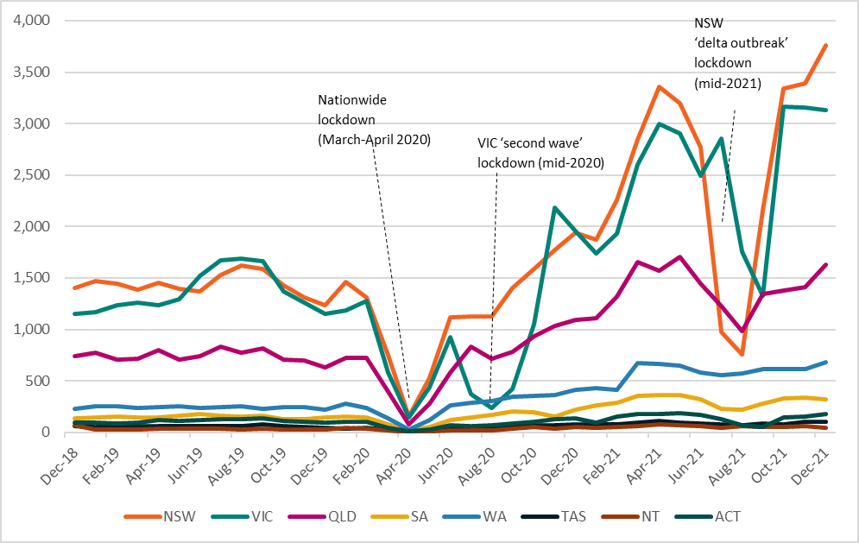

**Source**: National Skills Commission, Internet Vacancy Index Data, seasonally adjusted, December 2021.

N.B. The Internet Vacancy Index is based on a count of online job advertisements newly lodged on SEEK, CareerOne and Australian JobSearch during the month, it does not reflect the total number of job advertisements in the labour market.

In the medium to long term, the Accommodation and Food Services industry is projected to grow by 16.8 per cent between November 2020 and November 2025 (the fastest growth of any industry), requiring around 139,900 additional workers.[34]

Most of this demand will be for workers in cafés, restaurants, and takeaway food services (114,100 additional workers projected). Future jobs growth for Accommodation and Food Services is projected across most parts of Australia, with the strongest growth projected in Victoria (25.8 per cent) and Queensland (21.2 per cent). There may also be opportunities across other industries to provide Accommodation and Food Services, such as hospitality, catering or facility management for the Mining industry.

## Domestic and international tourism to drive demand for workers

As Australia’s domestic and international borders reopen, it is expected demand for workers in the Accommodation and Food Services will grow rapidly.

Many tourism businesses experienced significant challenges due to COVID-19 restrictions – these challenges were particularly acute for those with high international exposure (for example tour operators and travel agents) and for businesses in regions with a high reliance on international visitors or in regions with more extensive lockdowns.

The number of international visitors over the year to September 2021 was down 97.1 per cent from the year to September 2019 (pre‑COVID‑19).[35] By comparison, the number of domestic overnight trips fell by 29 per cent over the same period.[36] The impact of restrictions on tourism businesses was far greater for capital cities than regional areas[37] due to a greater reliance on international visitors and domestic business and event travellers.

The broader sector was also affected by many of its workers leaving or being unable to enter Australia due to the pandemic. The sudden reduction of a large proportion of international students and Working Holiday Makers reduced the number of available part-time and seasonal workers.[38]

Several stakeholders noted that as borders reopen and the number of international tourists returns to pre-COVID-19 levels (as well as an increase in international students and other overseas workers), the industry is expected to have very strong growth. This will provide employment opportunities for job seekers across the country. A shortage of workers will place a constraint on both industry recovery and growth.[39] At December 2021, the Accommodation and Food Services industry had the highest proportion of employers that expected to increase staff numbers over the next three months.[40]

## Flexible hours may suit job seekers, particularly the young, looking for flexible work

Many occupations in Accommodation and Food Services provide flexible hours. Around 61 per cent of workers are employed part-time[41], allowing workers to fit their jobs around school, study, caring and other commitments. The industry may provide opportunities for young people looking for their first job, or people looking for weekend work.

Young people under 25 years of age represent around 49 per cent of all Accommodation and Food Services workers[42], more than three times the national average for all industries.

Most entry level roles within this industry do not need prior experience or qualifications, with 38 per cent of roles at a Skill Level 5 (equivalent to a Certificate I or secondary education) – see *Figure 11*.

This provides an opportunity for job seekers to gain experience on the job, developing the skills necessary to progress a career within the sector or develop transferable skills for work in other industries over time.

For job seekers with limited work experience, there are opportunities to provide pre-employment training or work experience to ensure job seekers have core employability skills to take up roles in the sector including the confidence to undertake customer service focused roles.

More than half of people employed in the industry are employed on a casual basis, compared to less than 20 per cent of all employed persons.[43] There are opportunities to support job seekers interested in a career in the industry to connect with pathways to sustainable long-term employment, including skills and training opportunities. This could include opportunities to explore careers in skilled occupations in demand, such as chefs, cooks, and restaurant and hotel manager roles, which may also assist in addressing shortages of workers in these roles across the industry.

Figure 11. Skill Levels 2, 4 & 5 are most common among Accommodation & Food Services workers

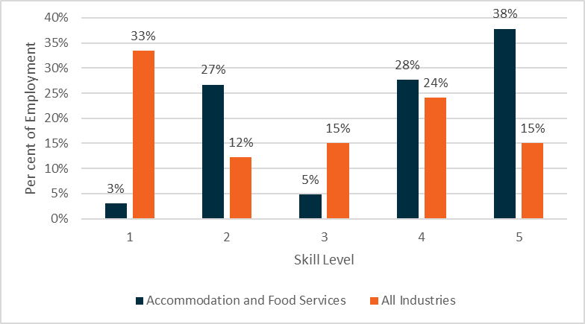

**Source**: Australian Bureau of Statistics, Labour Force Estimates, Customised Table - Employed Persons, by Industry Division of Main/Last Job, by Occupation of Main/Last Job, 2020, provided by the National Skills Commission.

The Accommodation and Food Services industry has a high number of jobactive job placements. Since July 2015, there have been over 275,000 job placements in the industry, with female job seekers representing more than 60 per cent of placements.[44] Many Workforce Australia job seekers will be well placed to take up roles in the industry.

**Key Points**

* The Accommodation and Food Services industry has been significantly affected by border closures and COVID-19 restrictions. The industry is recovering as vaccination rates rise and restrictions ease, noting uncertainty due to future outbreaks.
* Workers are needed across the industry to support short to longer-term domestic and tourism demand for services.
* The industry has a range of entry level roles that provide an opportunity for job seekers to gain valuable skills and work experience.
* Roles may provide flexibility for those looking to combine work with study, caring responsibilities, and other commitments.
* There is an opportunity for job seekers to connect to career pathways in the industry, including further skills and training.
* There is an opportunity to support greater workforce diversity and employment of job seekers, including for example mature age job seekers, people with disability and Aboriginal and Torres Strait Islander peoples.

# Agriculture, Forestry and Fishing

|  |
| --- |
| Industry snapshot The Agriculture, Forestry and Fishing industry includes agriculture, horticulture, aquaculture, forestry and logging, and fishing, hunting and trapping as well as support services.  As at November 2021, the Agriculture, Forestry and Fishing industry employed 316,000 people (2.4 per cent share of total employment). [45] The largest sectors in the industry are Sheep, Beef Cattle and Grain Farming; Fruit and Tree Nut Growing; and Agriculture and Fishing Support Services.[46] The top employing occupations[47] in the Agriculture, Forestry and Fishing industry are:   * Livestock Farmers * Crop Farmers * Mixed Crop and Livestock Farmers * Livestock Farm Workers * Crop Farm Workers.   The gross value of agricultural production in Australia is forecast to reach a record $78.0 billion in 2021–22[48] with an industry goal of $100 billion in agricultural production by 2030[49]. |

## The industry has shown resilience during COVID-19 though labour availability remains a challenge

The Agricultural, Forestry and Fishery industry has remained relatively resilient during the COVID-19 pandemic, with demand for food and essential items remaining stable both domestically and internationally. Over 90 per cent of food consumed in Australia is produced domestically, with around 70 per cent of Australia’s agricultural produce exported to trading partners.[50]

One of the main challenges for the industry has been international and domestic border restrictions which has reduced the availability of labour, particularly the number of non-employer-sponsored overseas workers (such as working holiday makers).[51]

Those sectors most affected by the reduction in the number of overseas workers include horticulture, some intensive production and meat processing.[52] The number of Working Holiday Maker visa holders and other overseas workers across the industry has significantly reduced as a result of border restrictions, as has the mobility of many workers domestically. The total number of workers used on horticulture farms is estimated to have declined by around eight per cent from 2019–20 to 2020–21, mainly due to the reduction in working holiday makers, while horticulture output remained relatively stable over the period.[53]

The Agriculture, Forestry and Fishing workforce has grown by 22,100 or 7.5 per cent over the five years to November 2021.[54] The industry is projected to grow by 4,100 or 1.2 per cent over the five years from November 2020 to November 2025.[55] This future employment growth for the industry is concentrated in regional and rural areas of Queensland (5,100) and New South Wales (3,700) with small declines expected in some other states.

This represents the net growth across the Agriculture, Forestry and Fishery industry. There are also short-term seasonal roles, as well as natural attrition as workers move to other roles, that may present opportunities for job seekers to gain skills and experience in the industry. For instance, on‑farm employment varies throughout the year, with a peak in February and low in June. This reflects the seasonality of some of the relatively labour-intensive work associated with planting and harvesting.[56]

The Agriculture, Forestry and Fishery industry also has a relatively older workforce, with around 43 per cent of workers aged 55 years and over, compared to an average of 20 per cent across all industries as shown in *Figure 12.* The industry is also relatively male-dominated, with around two in three workers being male.[57] There is an opportunity to promote greater workforce diversity by supporting a younger cohort of job seekers and female job seekers to take up roles within the industry.

Figure 12. Older age groups are over-represented in this industry

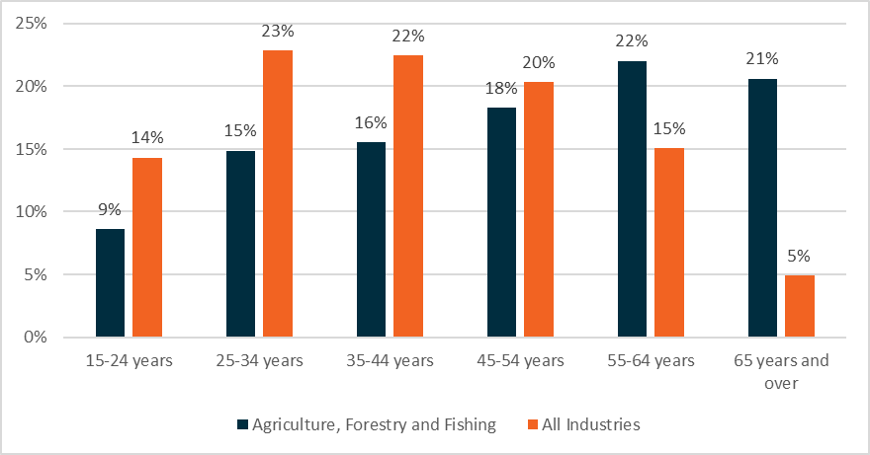

**Source**: Australian Bureau of Statistics, Labour Force, Detailed, Quarterly, National Skills Commission, seasonally adjusted, November 2021.

Additionally, the majority of the current agriculture workforce lives in regional and rural areas.[58] These areas generally have a thinner labour market, due to the smaller number of workers living in the area and limited access to skills and training opportunities. New workers living in metropolitan or other regional areas may need to relocate temporarily or permanently to take up opportunities in the industry. Considerations that may affect the movement of workers, includes the availability of affordable accommodation, transport and access to services. There are opportunities to connect a range of programs and initiatives that support job seekers to take up roles in the industry including access to relevant skills and training and other supports.

Employment in the Agriculture, Forestry and Fishery industry has historically been concentrated in roles at Skill Level 1 and Skill Levels 4 and 5 (refer to *Figure 13,* see *Figure 5* for skill level definitions). At Skill Level 1, this reflects the high number of farmers and farm managers across the industry. At Skill Levels 4 and 5, this reflects the high number of farm workers and plant operators across the industry. However, the Australian Bureau of Statistics has undertaken a targeted update of ANZSCO which was released on 23 November 2021.[59] The update includes introducing a new minor occupation group ‘Primary Production Supervisors and Specialists’ which is expected to increase the proportion of Agriculture, Forestry and Fishery workers at Skill Level 3.

Figure 13. Skill level among Agriculture, Forestry and Fishery workers

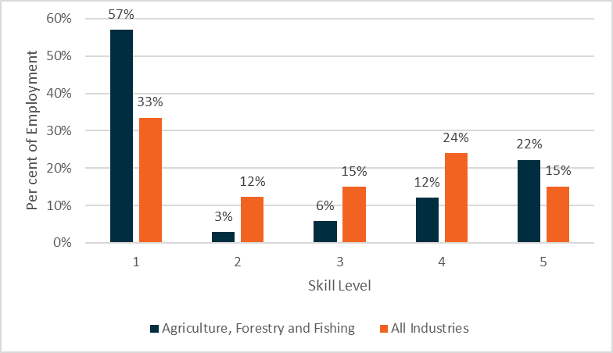

**Source**: Australian Bureau of Statistics, Labour Force Estimates, Customised Table - Employed Persons, by Industry Division of Main/Last Job, by Occupation of Main/Last Job, 2020, provided by the National Skills Commission.

## A skilled and available workforce is needed to support growth in production

To support the workforce needs of the Agriculture, Forestry and Fishery industry, a range of industry‑specific commitments are in place, including:

* The Australian Government Response to the *National Agricultural Workforce Strategy*[60] and the *Australian Government Roadmap to attract, retain, upskill and modernise the agricultural workforce* (Roadmap)[61], which were released following the National Agricultural Labour Advisory Committee’s development of the *National Agricultural Workforce Strategy: learning to excel* report.[62]
* *Delivering Ag2030*[63] outlines the Government’s seven themes for supporting industry to achieve its goal of $100 billion in agricultural production by 2030. This includes a human capital theme to ensure people and their commodities across the industry and supply chain have the support, infrastructure and skills they need.
* The *National Agricultural Innovation Policy Statement[64]* released on 11 October 2021 established a Digital Innovation Priority, which identifies a digitally skilled workforce as crucial to Australia becoming a mature adopter, developer and exporter of digital agriculture.

The Roadmap outlines the government’s vision and a framework for the sector:

“The Australian Government’s vision is for farmers, agribusinesses and associated supply chains to have access to sufficient and appropriately skilled workers to support a modern, innovative, resilient and growing agricultural sector”. [65]

The Government has also announced a range of workforce initiatives to support access to labour across the industry as well as improve employment conditions.[66] These include:

* support to assist job seekers to move to rural and regional areas to take up short-term agricultural work[67]
* initiatives to ensure workers are treated fairly and ethically[68]
* restarting arrivals under the Pacific Australia Labour Mobility (PALM) scheme as well as facilitating the redeployment of Pacific and Timorese workers already in Australia[69]
* introduction of an Australian Agriculture Visa[70]
* initiatives that focus on shifting the perceptions of modern agriculture and providing upskilling and career progression opportunities.[71]

This builds on a number of existing initiatives including the Harvest Trail Services,[72] which help connect workers with employers in harvesting areas across Australia.

## The industry provides opportunities for work and career pathways

The Roadmap identifies linked themes for government and industry action. Securing the agricultural workforce is one of these themes and includes the need to build awareness of career pathways across the industry and seasonal job opportunities. The emphasis on career pathways aligns with the focus in the Roadmap of upskilling and retaining workers.[73]

Seasonal work within the industry provides an opportunity for job seekers to experience working in the industry or to combine work with study periods or a gap year. This may also lead to further study or a career within the Agriculture, Forestry and Fishing industry.

There are a range of roles across the sectors within the industry that may provide career pathways for job seekers. For example, in addition to seasonal harvesting roles, there are a range of other roles throughout the year to support agricultural production, including planting, pruning, thinning and packing. In addition to on-farm and other industry specific roles, there are a range of support service roles that may provide opportunities to work in the industry, such as Bookkeepers, General Clerks and Truck Drivers.[74]

Technological advancements and digitisation are also affecting the future workforce needs of the Agriculture industry. By 2030, one in three new jobs created in the industry will be technology related.[75] This will influence the training and support job seekers need to take up work within the sector and potential career pathways they can explore.

**Key Points**

* The Agriculture, Forestry and Fishing industry has a range of year-round and seasonal employment opportunities – this includes on-farm/industry specific roles and support services roles.
* There are a range of Government initiatives to support job seekers and other workers to meet labour force needs in the Agriculture, Forestry and Fishing industry – any Workforce Specialist projects in this industry would need to complement and/or leverage existing initiatives.
* Seasonal work may provide job seekers with valuable work experience and may lead to further study or a career in the industry.
* The industry has a relatively older and male-dominated workforce, presenting opportunities to support greater workforce diversity, such as young people, women, people with disability and Aboriginal and Torres Strait Islander peoples.

# Construction

|  |
| --- |
| Industry snapshot The Construction industry includes businesses mainly engaged in the construction of buildings and other structures, heavy and civil engineering construction, and other construction services. Examples of industry work include house renovations, bridge maintenance, earthmoving, pipeline construction, mine-site construction, roof tiling, plumbing, air conditioning installation, electrical wiring, painting and carpentry.  The industry employs around 8.7 per cent of Australian workers.[76] The highest employing occupations[77] are:   * Carpenters and Joiners * Electricians * Construction Managers * Plumbers * Building and Plumbing Labourers.   Employment in the Construction industry is projected to grow by 6.8 per cent over the five years from November 2020 to November 2025 (approximately 80,700 jobs).[78]  The Construction workforce is predominantly male, with only 13 per cent of workers female.[79]  Most Construction workers are employed full-time.[80] Self-employment is also common, with more than one in three Construction workers ‘being their own boss’.[81]  It is one of the most common industries for jobactive participants to be placed into jobs.[82] |

## The industry is recovering, with skill shortages across a range of occupations

The Construction industry has been negatively impacted by COVID-19 lockdowns around the country, though not as significantly as some other industries. As at November 2021, the Construction industry had an estimated 1,143,600 workers. This is 3.5 per cent lower than the estimated 1,185,200 workers in February 2020 prior to widespread COVID-19 lockdowns in Australia.[83]

Parts of the industry continue to rebound strongly. For example, looking at job advertisements in December 2021 compared to pre-COVID levels, the strongest gains of any major occupational group were recorded for Labourers (up by 119 per cent or 11,600 job advertisements) as well as strong gains for by Machinery Operators and Drivers (69 per cent or 5,400 job advertisements). This compares to a 46 per cent increase for the entire labour market.[84] Some of this recruitment activity relates to employers reengaging workers separated from employment during the pandemic.[85]

In the 2021 Skills Priority List, shortages are identified for several Construction occupations including, welders, electricians, bricklayers, carpenters and plumbers.[86] Some of these occupations are in demand across multiple industries.

Investment in a range of infrastructure and construction projects will require a ready and deployable workforce. Over the next five years, investment in major public infrastructure across Australia will exceed $218 billion.[87] At the same time, investment activity in residential and non-residential building as well as private engineering construction (such as mining and heavy industry construction) will also continue to support demand for workers in the industry.[88] Construction demand associated with the clean energy economy, particularly renewable energy construction, will also support new jobs and workforce opportunities.[89]

Looking into the future, jobs in Construction are projected to rise by 80,700 (or 6.8 per cent) over the five years from November 2020 to November 2025. Supported by Government stimulus measures, jobs are projected to grow strongly in Building Installation Services (up 23,900 or 8.4 per cent) and in Residential Construction (16,300 or 10.6 per cent). In addition, significant infrastructure investment is reflected in the growth forecast for the Heavy and Civil Engineering Construction sector (up 9,900 or 8.8 per cent). [90]

Future jobs growth for Construction is projected in most parts of Australia, with above average growth in the five years to 2025 projected in New South Wales (9.1 per cent) and Victoria (8.8 per cent), though declines are forecast for both Tasmania (-2.2 per cent) and the Northern Territory (‑5.3 per cent).[91]

## A wide range of occupations, though most have mandatory entry requirements, and many are physically demanding

Several stakeholders highlighted the range of roles available in the Construction industry, and the opportunities that will be created by large infrastructure spending by the Australian and state/territory governments in both metropolitan and regional areas.

Full-time jobs are common in the Construction industry, with 84 per cent of workers employed   
on a full-time basis.[92] This is considerably higher than the 69 per cent average across all industries.

For new entrants to the industry, basic qualifications (in particular a White Card), having suitable clothing and physical fitness were identified by stakeholders as being critical to many entry-level Construction roles. There are opportunities to support job seekers to meet these entry level requirements to commence employment in the industry.

The importance of physical fitness for many roles is supported by data available on the YourCareer website. Of the 213 occupations listed in the Construction industry, around half (105) are classified as physically demanding, such as bricklayers, carpenters, plumbers and scaffolders.[93]

Self-employment is common in Construction, with 35 per cent of workers self-employed.[94] There is an opportunity to provide support to job seekers to establish themselves as a self-employed contractor, including connecting with initiatives providing self-employment assistance.

## Most workers are male, but there are efforts to attract and retain more women in the industry

Construction is traditionally a male-dominated industry with female employment across the industry representing around 13 per cent of the workforce.[95] Women are significantly underrepresented across a range of occupations in Construction. *Figure 14* shows the major occupation groups in Construction, and how they are split between male and female workers. The largest concentration of female employment in the industry is among clerical and administrative workers, while very few are employed as labourers or in technical/trade occupations.

Figure 14. Most major occupation groups in Construction have a majority of male workers (000’s)

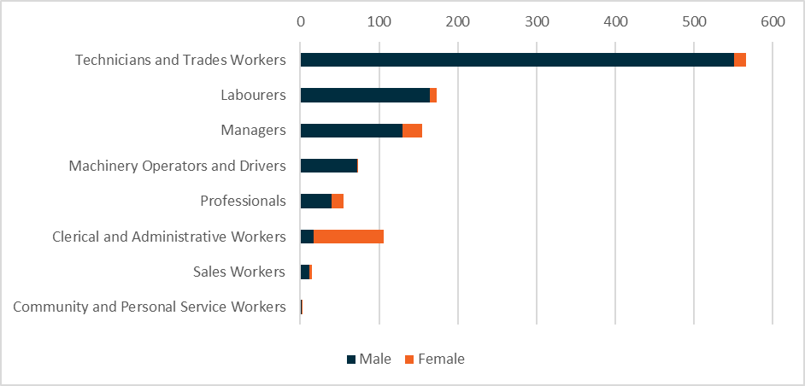

**Source**: Australian Bureau of Statistics, Labour Force, Detailed, Quarterly, November 2021.

Among jobactive participants, only eight per cent of job placements recorded in the Construction industry (since July 2015) have been for females, further highlighting this gender imbalance.[96] There is an opportunity to promote greater workforce diversity by supporting female job seekers to take up roles within the industry.

The Government is focused on ensuring increased participation of women in apprenticeships and traineeships, including trade related apprenticeships, and has a number of measures in place to support women in training. This includes additional supports to be delivered by Australian Apprenticeship Support Network providers, such as:

* additional Gateway Service places for women interested in taking up a non-traditional trade
* guaranteed in-training support services for women commencing in a non-traditional trade occupation, and
* $3.9 billion investment in the Boosting Apprenticeship Commencements (BAC) wage subsidy and a further $716 million through the Completing Apprenticeship Commencements (CAC) wage subsidy.[97]

A range of efforts are also being made to support more women to enter and remain in the industry, including the Women Building Australia initiative[98], the Women in Apprenticeships fund[99], Launch into Work[100] and the Career Revive program[101]. Cultural change is also a key factor in supporting more women to enter and remain in the industry. Across all industries, the Government’s Roadmap for Respect responds to the Human Rights Commission’s recommendations outlined in the Respect@Work report. The Roadmap provides a path for action to achieve cultural change and to create safer workplaces for all Australians. Some of the actions include establishing a Respect@Work Council, developing the Respect@Work website and developing a package of training and education resources for workers and employers.[102]

## Apprenticeships and traineeships are a common entry pathway

The Construction industry is the biggest user of apprenticeships and traineeships of any industry. Over the five years to December 2020, the Construction industry had 22 per cent of apprenticeship/traineeship commencements (the next highest industry was the Administrative and Support Services industry with 12.8 per cent).[103] For job seekers looking to enter the industry, a trades apprenticeship is a common pathway, with many Australian Government supports available to assist.[104]

This is also reflected in the workforce’s skill level. Almost half of workers are at Skill Level 3, equivalent to a Certificate IV or III qualification (including at least two years on-the-job training) – see *Figure 15 (*see *Figure 5* for skill level definitions).

Figure 15. Skill Level 3 roles are more common among Construction workers

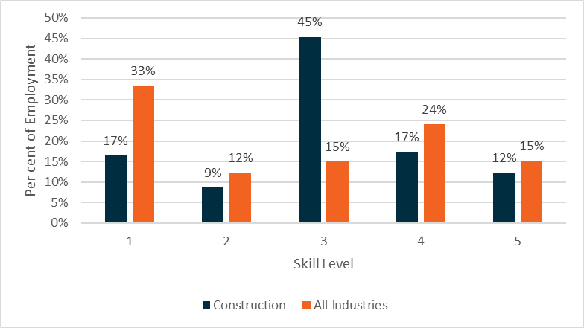

**Source**: Australian Bureau of Statistics, Labour Force Estimates, Customised Table - Employed Persons, by Industry Division of Main/Last Job, by Occupation of Main/Last Job, 2020, provided by the National Skills Commission.

Recently, the number of commencements in apprenticeships and traineeships has surged across many industries, aligning in timing with the introduction of the Australian Government’s BAC wage subsidy. While the December quarter is not usually a particularly busy quarter for commencements, the number of apprenticeship and traineeship commencements jumped dramatically in the December 2020 quarter. Within the Construction industry, there was a more than two-fold increase in commencements compared to the corresponding period a year earlier.[105] The CAC wage subsidy for BAC‑eligible employers, will support employers in the construction industry by extending financial support in the second and third year of an Australian Apprenticeship.

The Construction industry has a high number of jobactive placements, with over 188,800 job placements since July 2015.[106] This indicates that many job seekers in the new model are likely to be suitable for work in the industry. There are opportunities to support job seekers to take up and complete an apprenticeship or traineeship as a pathway into the industry, and to sustainable long-term employment.

**Key Points**

* Significant public and private investment across the industry needs a ready and deployable workforce, including a range of opportunities for job seekers.
* There are a range of entry level roles within the industry – job seekers may require support to gain relevant licences/induction (e.g. a White Card) to take up these roles.
* Apprenticeships and traineeships provide a pathway for job seekers to take-up opportunities in the industry while gaining qualifications.
* There is an opportunity to support greater workforce diversity, including gender diversity across the male-dominated industry and employment of other groups such as Aboriginal and Torres Strait Islander peoples.

# Health Care and Social Assistance

|  |
| --- |
| Industry snapshot Health Care and Social Assistance is Australia’s largest employing industry and includes medical services, allied health, residential care, social assistance and early childhood education and care services.  The Health Care and Social Assistance industry accounts for 14.4 per cent of Australian workers.[107]  The top employing occupations[108] in the Health Care and Social Assistance industry are:   * Registered Nurses * Aged and Disabled Carers * Receptionists.   Close to half of this workforce is employed part-time and it is a female-dominated industry, with nearly four out of five workers being female[109].  There is strong demand for workers in the industry, especially for roles such as personal care workers[110] and early childhood educators.  Job placements for jobactive participants in the Health Care and Social Assistance industry tend to be more sustainable compared to other industries.[111] |

## Strong employment growth projected to continue with growing demand for services across the industry

There are currently 1.9 million people employed in the Health Care and Social Assistance industry.[112]

The Health Care and Social Assistance industry is projected to need an additional 249,500 workers based on 2020 projections to November 2025.[113] The industry growth is projected across all states, territories, capital cities and regional areas. [114]

Much of this growth is being driven by strong demand as well as continued government investment. Australia’s aging population is a key factor in increasing demand for aged care services. There is also growing demand for care and support services under the National Disability Insurance Scheme (NDIS) due to the growth in the number of NDIS participants[115] as well as for early childhood education and care services[116] due to increasing labour force participation.

To support the workforce needs of these sectors, industry specific workforce strategies and plans are already in place, including:

* A Matter of Care: Australia’s Aged Care Workforce Strategy (June 2018)[117]
* NDIS National Workforce Plan: 2021–2025[118]
* Shaping Our Future: National Children’s Education and Care Workforce Strategy 2022-31[119].



The National Skills Commissioner was also asked to undertake an in-depth study of the needs of the care and support workforce to 2050.

Insights from these strategies and studies have informed the development of this Framework, particularly in relation to workforce needs that could be met by job seekers with the support of a Workforce Specialist project.

The industry continued to experience strong employment demand during COVID-19 as shown in *Figure 16*. In the five years to November 2021, the industry grew by 350,100 employed persons[120], a relatively steady increase across the period without the significant falls in employment at the start of the pandemic experienced by many industries.

Health Care and Social Assistance is a female dominated industry, with approximately 76 per cent of workers female.[121] The industry’s age profile is relatively consistent with the average across all industries, with 21 per cent of workers aged 55 and over (compared to the average of around 20 per cent across all industries). Though, young people aged 15–24 years represent only 10 per cent of the workforce in the industry (compared with the average of 14 per cent across all industries).[122]

There is an opportunity to promote greater workforce diversity including by supporting male job seekers and youth to take up roles within the industry. There is an opportunity to increase the workforce participation of people with disability, Aboriginal and Torres Strait Islander peoples and people from culturally and linguistically diverse backgrounds in the industry. Workforce diversity is also important to ensure individuals have access to appropriate care and support to meet their needs including access to culturally appropriate and safe services.[123]

Figure 16. The industry continued to experience strong demand during COVID-19

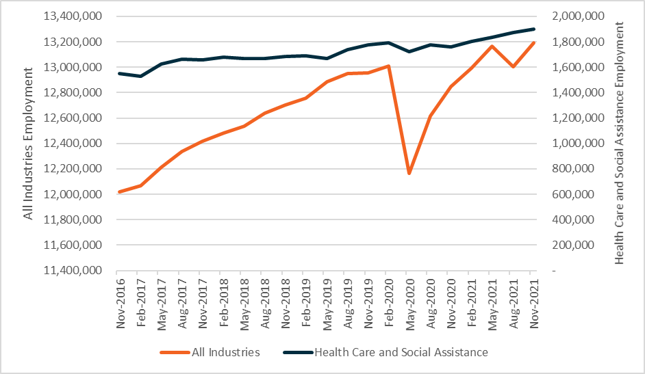

**Source**: Australian Bureau of Statistics, Labour Force, Detailed, Quarterly, Seasonally Adjusted, November 2021.

N.B. Dual axis used to distinguish employment trend.

Figure 17. Skill Levels 1 and 4 are most common among Health Care and Social Assistance workers

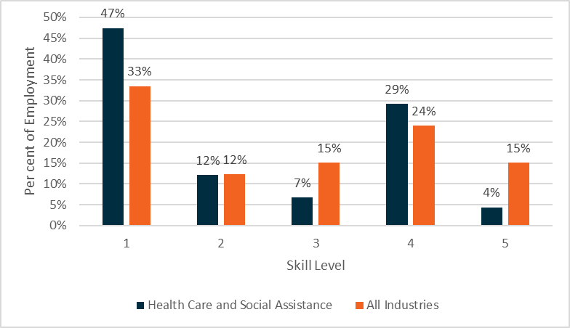

**Source**: Australian Bureau of Statistics, Labour Force Estimates, Customised Table - Employed Persons, by Industry Division of Main/Last Job, by Occupation of Main/Last Job, 2020, provided by the National Skills Commission.

Employment in the Health Care and Social Assistance industry is concentrated in roles at Skill Level 1 and Skill Level 4 (refer to *Figure 17* andsee *Figure 5* for skill level definitions). Skill Level 1 reflects the high number of professionals, such as General Practitioners and Registered Nurses, with bachelor degree or above qualifications common across the industry. Skill Level 4 reflects the high number of personal care workers[124] as well as support roles, such as receptionists and general clerks, across the industry.

## Growing personal care sector will need to attract new workers

Personal care workers deliver services to provide individuals with high quality care that is safe, meets individual needs and supports their quality of life.[125]

The personal care workforce represents 17 per cent of the Health Care and Social Assistance industry.[126] The personal care workforce is projected to continue to grow, requiring an additional 60,000 workers over the five years from November 2020 to November 2025.[127] Attraction of new workers, as well as the retention of existing workers, will assist in meeting these needs across the industry. Aged care, disability support and veterans’ care are all highly connected with providers operating across these sectors and workers often transitioning between sectors.[128]

Personal care workers will usually need to meet a number of general requirements to work in the industry, such as undergoing a police check, completing a Working with Children and Vulnerable People Check and, particularly in aged care, need to receive certain vaccinations. Some sectors may also have specific entry requirements that some workers may be required to meet, such as the national NDIS Worker Screening Check, or completion of a course on Infection Prevention and Control.[129]

Depending on the sector, the employer and the specific role, personal care workers may also be expected to hold a Certificate III or higher relevant qualification (such as a Certificate III in Individual Support). Traineeships may provide workers with a pathway to gaining relevant qualifications.

Anecdotally, some stakeholders identified that having sufficient time and resourcing available to train and supervise workers can be a challenge.[130] During consultations on this Framework, stakeholders also highlighted challenges in relation to sufficient capacity to support students to undertake work placement hours as part of their Certificate III or above. Workforce shortages may be more acute in regional and remote communities, where it may be harder to attract workers to the sector and/or the area.[131] There is an opportunity to provide support to the industry to attract job seekers to personal care work and look at mechanisms to provide the training and supervision needed for new and upskilling workers.

In addition to these skills and qualifications, stakeholders consistently identify the importance of the attributes and values[132] an individual brings to a care and support role.[133] Many employers will look for candidates who share the organisation’s values to support the delivery of quality care to meet an individual’s needs.

There are opportunities for job seekers who have these shared values/attributes and meet the general requirements to take up personal care worker roles with appropriate support and training. This may include progressing to study a formal qualification over time. There are also a range of Government initiatives to support people to take up a role in personal care, as part of broader efforts to grow a skilled aged care[134] and disability support[135] workforce.

For example, the Government will invest an additional $500 million, to be matched by state and territory governments, to expand the JobTrainer Fund to ensure Australians can skill up, including around 33,800 additional training places in the aged care sector.[136]

Personal care work may provide a pathway to further study and career progression in the industry in relation to roles in nursing and allied health.

Caring and support roles may offer a pathway to engage or reengage in the workforce for job seekers looking for flexible hours to balance study, training or personal caring commitments, with a high proportion of personal care workers employed on a part-time basis.[137]

## Early Childhood Education and Care

As part of the industry classification, ANSZIC[138], used to inform this Framework, the Child Care Services sector falls under the broader Health Care and Social Assistance industry. Child carers, generally known as early childhood educators, may be employed in either the Education and Training industry, in preschool or early childhood education and care settings, or the Health Care and Social Assistance industry, reflecting the role this occupation plays in supporting children’s learning and development.

At November 2021, there are 134,200 early childhood educators employed in Australia with men underrepresented in this occupation, making up only four per cent of this workforce.[139] Early childhood educator roles are expected to grow by around 10 per cent from November 2020 to November 2025[140] and are identified as an occupation in national shortage with strong demand on the Skills Priority List.[141]

Early childhood educators must hold or be ‘actively working towards’ at least Certificate III level education and care qualification approved by the Australian Children’s Education and Care Quality Authority.[142] Early childhood educators may also be required to undertake other training such as first aid and other emergency care training.

Many opportunities exist for job seekers to take up early childhood educator roles while they learn on the job and actively work towards their qualification. This includes though traineeships, which provide a supported pathway for job seekers to commence a career within the sector.

## Other supporting roles provide an opportunity to work in the industry

Several stakeholders noted there are a range of support roles across the Health Care and Social Assistance industry, such as receptionists, general clerks, kitchenhands and commercial cleaners.[143] Around 15 per cent of people employed across the industry are employed in these types of roles which are generally Skill Level 4 or 5.[144]

These support roles provide job seekers an opportunity to work in this industry as well as the flexibility to work across other industries with similar roles. These roles may provide job seekers experience in the industry with the potential to move into industry specific roles, such as personal care work or early childhood education and care, over time.

**Key Points**

* Strong employment growth is projected across these sectors including aged care, disability support and veterans’ care as well as early childhood education and care. This is driven by the ageing population, with an increase in the participation rate and government investment.
* A range of workforce strategies are in place across specific sectors, including aged care, the NDIS, and children’s education and care, to support the attraction and retention of a skilled workforce.
* There are opportunities to join the personal care workforce for job seekers with the shared values and attributes of employers, who meet entry level requirements and have the capacity to develop the skills (and in some circumstances qualifications) required.
* Traineeships and on-the-job experience provide a pathway for job seekers interested in early childhood education to take-up opportunities in the sector while gaining qualifications.
* There are a range of other support service roles, often at Skill Level 4 or 5, that provide opportunities for job seekers to enter the industry.
* There is an opportunity to support gender diversity across the female-dominated industry and more young people into roles in the industry.
* There is an opportunity to increase employment of job seekers, including for example people with disability, Aboriginal and Torres Strait Islander peoples and people from culturally and linguistically diverse backgrounds.

# Manufacturing

|  |
| --- |
| Industry snapshot The Manufacturing industry is the seventh largest employing industry, with 864,300 people employed in the industry (6.6 per cent of Australian workforce).[145] The top employing occupations[146] related to the production elements of the industry are:   * Structural Steel and Welding Trades * Production Managers * Packers * Metal Fitters and Machinists * Food and Drinks Factory Workers.   Almost 70 per cent of production roles are at Skill Levels 3, 4 and 5[147] and around 30 per cent are employed regionally[148].  The Manufacturing industry is currently the fifth largest industry for job placements for jobactive participants.[149]  The Manufacturing industry as defined within ANZSIC[150], focuses on the production elements of the industry. This includes work related to the transformation of materials into new products such as the manufacturing of food and beverage products, clothing and footwear, wood, metal and other material products, machinery and equipment and furniture. Globally, the manufacturing industry is transforming rapidly. New technologies and methods of production are enabling a shift from mass production to more bespoke, advanced and higher value manufacturing, where design and associated service delivery are as important as the production process itself.  This means that the above jobs figures do not represent the full scale of employment in manufacturing, with growing opportunities in a diverse range of jobs across the value chain, from research and development, to design, logistics and after-market maintenance and services. |

## Manufacturing supports and enables other industries across the economy including as part of the COVID-19 response

The COVID-19 pandemic has highlighted the importance of manufacturing capabilities and its role in building resilience to shocks, adding value to primary producers, lifting industry productivity and supporting job creation and growth.

Manufacturing is both a supplier for and purchaser from a wide range of other industries including the extractive industries, agriculture, utilities, construction, and the services sector. In 2018–19,   
88 per cent of Australia’s domestic manufacturing output was used as inputs for production in other industries and produced end-level products for consumers. At the same time, Australian manufacturers sourced 70 per cent of their inputs from other industries.[151] Manufacturing is an important contributor to regional Australian with almost 1 in 3 manufacturing workers located in regional areas.[152]

Manufacturing is also a major exporter. In the 12 months to June 2021, manufacturing in Australia generated around $115 billion in gross value added (GVA)[153] to the national economy.[154] Australia’s established heavy industries – primarily aluminium, steel, cement and plastics and chemical manufacturing – are a significant contributor to Australian manufacturing. In 2018-19, heavy industry accounted for 25 per cent of GVA and 16 per cent of employment in the manufacturing industry.[155]

The manufacturing industry is also supporting the COVID-19 recovery. The Modern Manufacturing Strategy (MMS)[156] was released in October 2020, with additional support announced in the 2021–22 Budget. The MMS focuses on areas of greatest competitive, comparative and strategic advantage through the six new National Manufacturing Priorities: Space; Medical Products; Resources Technology and Critical Minerals Processing; Food and Beverage; Defence; and Recycling and Clean Energy.

## Existing skills shortages in Manufacturing are exacerbated by the pandemic

While Australian manufacturing experienced an expansion phase in late 2020 and the first half of 2021, employment in the manufacturing industry has been relatively volatile.[157] Feedback from industry during the development of the National Manufacturing Priority Roadmaps identified a lack of skilled workers as the key cross-cutting barrier to the growth and transformation of Australian manufacturing. [158] These skills gaps have been exacerbated by the COVID-19 pandemic, due to limited access to the international labour market, reduced domestic mobility and changes to patterns of work.

Although some of the urgent skills needs fall into Skill Level 1 and 2 jobs (such as engineering and technical skills), the feedback indicated that there are significant opportunities for workers with Skill Levels 3–5 across the National Manufacturing Priorities, with manufacturers reporting shortages in:

* Workers with information technology, digital, and automation skills
* Workers with technical training through vocational pathways such as laboratory technicians
* Defence manufacturing personnel including in textile and machinery work
* VET skilled apprentices working in welding, electrical, metal fabrication, and metal and mineral processing.

## Currently most manufacturing production related workers are male and working in jobs in Skill Level 3 and 4 roles

Manufacturing is currently trade and technician dominated with male employment making up the majority of this occupation group (see *Figure 18*). Overall, less than one in three workers within the industry are female.[159] Women are represented across most major occupation groups but there are opportunities to increase female participation across all occupations and skill levels in the industry.

Figure 18. Manufacturing is male-dominated across the majority of occupation types (000’s)

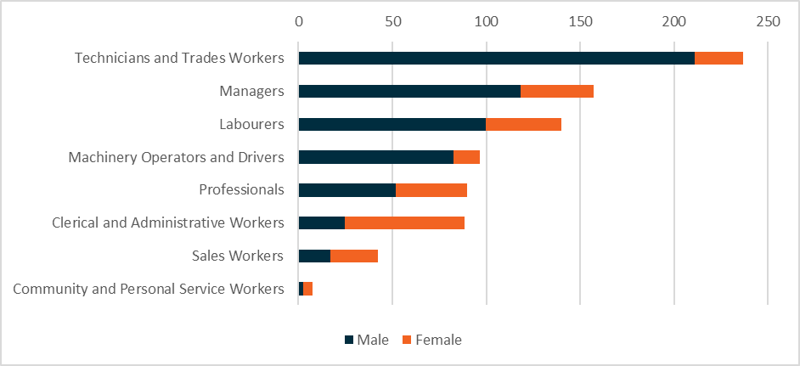

**Source:** Australian Bureau of Statistics, Labour Force, Detailed, Quarterly, November 2021.

Full-time roles are common in the Manufacturing industry, with 82 per cent of workers employed   
on a full-time basis (compared to 69 per cent across all industries).[160]

Currently, Manufacturing roles are broadly dispersed across skill levels, with almost 70 per cent of roles at Skill Levels 3, 4 and 5 (see *Figure 19* and see *Figure 5* for skill level definitions). There are opportunities for job seekers to take up roles at these skill levels within the industry with appropriate training and support. This includes VET and apprenticeship and traineeship pathways and the potential for further training or study over time to support career progression.

Figure 19. Manufacturing roles are broadly dispersed across skill levels

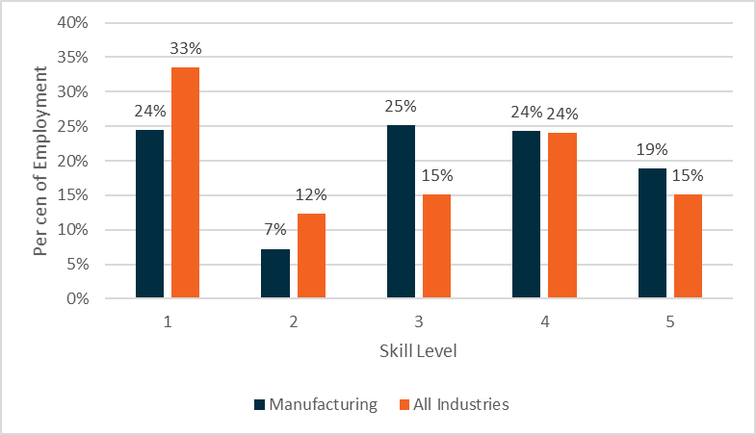

**Source**: Australian Bureau of Statistics, Labour Force Estimates, Customised Table - Employed Persons, by Industry Division of Main/Last Job, by Occupation of Main/Last Job, 2020, provided by the National Skills Commission.

## Manufacturing is undergoing a transformation towards advanced, higher-value activities

The Manufacturing industry is transitioning away from production towards advanced manufacturing. The figure below (*Figure 20*) provides a visual representation of value added along a production cycle. It sets out the range of activities of modern manufacturing and the move towards high-value activities.

Figure 20. Outline of the manufacturing value chain demonstrates range of employment opportunities across the sector

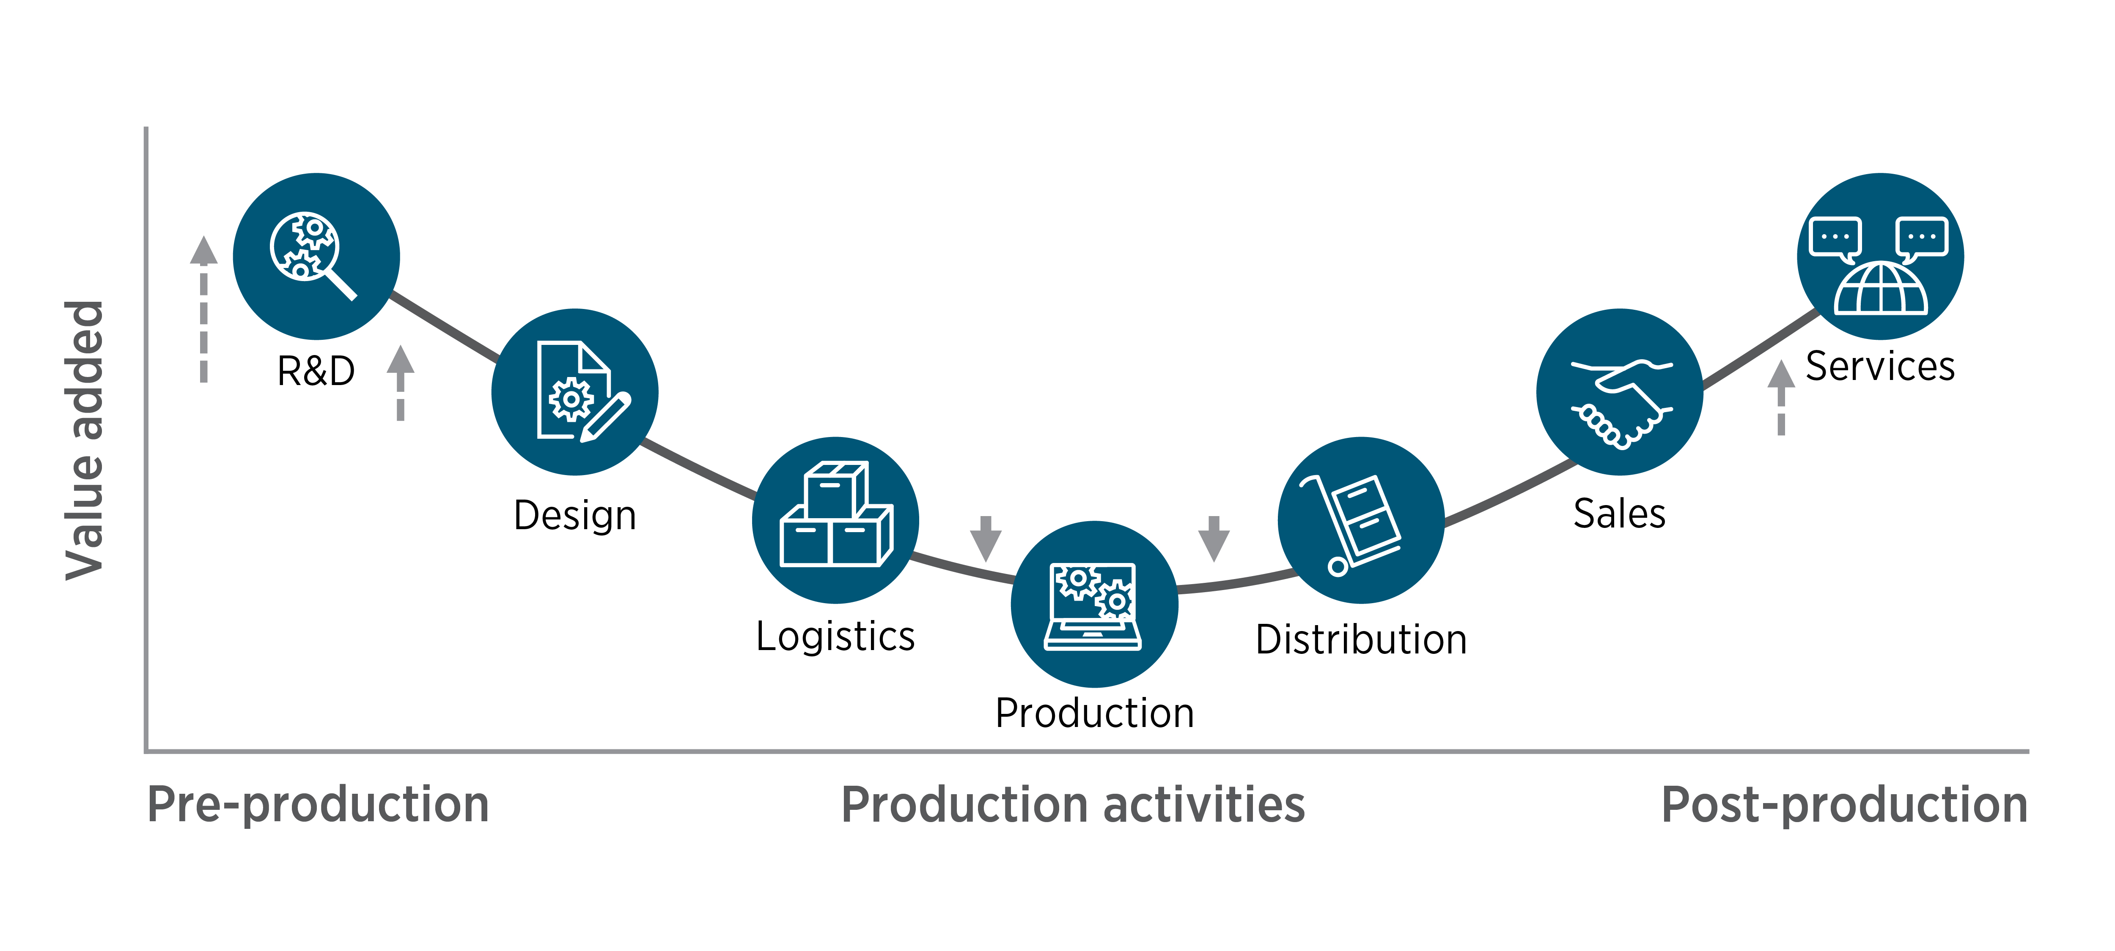

**Source:** Australian Government Department of Industry, Science, Energy and Research, Make it Happen: The Australian Government’s Modern Manufacturing Strategy, October 2020.

While production will always be important, there is value in activities pre and post-production by embracing digital technologies and developing high value added products and services for the global market.[161] The skills required for the roles associated with all these activities will vary, providing opportunities for job seekers across a range of roles.

As the manufacturing industry continues to transform there will likely be opportunities to transition and reskill existing production focused manufacturing workers towards jobs in higher value activities, as these activities will require both skills and intimate knowledge of the industry.[162] These higher value activities may also present an opportunity for job seekers in roles that may be relatively less labour intensive than some production roles, providing an opportunity to increase the diversity of the Manufacturing workforce.

Although the National Skills Commission projects employment across the Manufacturing industry to marginally decrease in the five years from November 2020 to November 2025[163], the transforming industry is still a significantly large employer with opportunities for job seekers across all activities from pre to post-production.

Additionally, new job opportunities are also likely to emerge in the established heavy manufacturing industries as they begin to decarbonise as part of the *Australian Government’s Long-Term Emissions Reduction Plan*, which has a focus on low emissions steel, aluminium and alumina, and other emerging industries, such as clean hydrogen. There may be new opportunities for workers in these industries to retrain and upskill into new jobs. The opportunity to export low emissions products may also create indirect jobs within the manufacturing industry.[164]

## There are employment opportunities in all six National Manufacturing Priorities

Each National Manufacturing Priority has the potential to deliver workforce opportunities. In particular, Australia’s global strengths and reputation in the Resources Technology and Critical Minerals Processing, Food and Beverage, and Defence National Manufacturing Priorities present significant opportunities for job seekers at Skill Levels 3 and 4, as they produce high-quality products for global market partners.

Apprenticeships, traineeships, and on-the-job skills development can provide a pathway for job seekers at these skill levels in occupations across the National Manufacturing Priorities, such as:

* Metal fabricators
* Welders
* Fitters and turners
* Aircraft maintenance
* Vehicle painters
* Laboratory technicians
* Medical sales representatives

Current and future demand across the National Manufacturing Priorities is still being explored and refined as the industry supports the COVID-19 recovery.

**Key Points**

* The Government’s Modern Manufacturing Strategy outlines the priorities and transformation of the Manufacturing industry over the next 10 years, which will influence the workforce opportunities and career pathways for job seekers.
* Apprenticeships, traineeships, and on-the-job skill development can provide a pathway for job seekers in high-need areas such as welding, electrical, metal fabrication and defence manufacturing jobs.
* Although there is increasing demand for higher skilled jobs in manufacturing, opportunities remain for jobs seekers across the industry both now and in the future.
* Entry-level jobs in manufacturing present job seekers with an opportunity to upskill and reskill as the industry undergoes a transformation to high-technology, higher value manufacturing activities.
* There is an opportunity to support greater diversity across the manufacturing industry, including increasing female participation across a range of occupations as well as participation of other groups of job seekers including for example people with disability and Aboriginal and Torres Strait Islander peoples.

# Retail Trade

|  |
| --- |
| Industry snapshot The Retail Trade industry refers to businesses that primarily sell goods to the general public  (as opposed to businesses or government). Examples of retail businesses include supermarkets, newsagents, florists, pharmacies, petrol stations and department stores.  The Retail Trade industry employs 1 in 10 Australian workers.[165] The highest employing occupations[166] in the retail industry are:   * Sales Assistants (General) * Retail Managers * Checkout Operators and Office Cashiers * Shelf Fillers.   Many retail industry vacancies don’t require prior experience or qualifications, making it an attractive industry for people entering the workforce for the first time.  Around one in three retail workers are youth (15–24 years of age).[167] |

## Continued growth expected, despite a shift towards online retailing

The Retail Trade industry is Australia’s second largest employing industry with 1.28 million workers.[168] The industry was hit hard by COVID-19 lockdowns, with many workers stood down or retrenched. The easing of public health restrictions on the east coast of Australia in late 2021 resulted in an increase in employment, following a similar V-shaped recovery that occurred in the second half of 2020 following an easing of restrictions – see *Figure 21*.

Longer term, the industry is projected to grow by 4.1 per cent over the five years from November 2020 to November 2025, requiring an estimated 52,500 additional workers.[169] This jobs growth is projected across most parts of Australia, with the largest and strongest growth projected in Greater Sydney (7.7 per cent) and Greater Melbourne (5.9 per cent).

While the long-term trend towards online retailing has continued over recent years, this trend has been greatly accelerated by extended lockdowns in many parts of Australia due to COVID-19. For example, in September 2021, the proportion of online sales peaked at 14.6 per cent of all retail sales, the highest proportion since retailing data has been collected and twice the proportion recorded in February 2020 prior to the first lockdowns in Australia. In November 2021, the proportion of online sales decreased slightly to 12.5 per cent, reflecting increased in-store sales following the ending of lockdowns across multiple states and territories. [170]

While online retailing generally employs fewer workers than traditional bricks-and-mortar retailing, jobs continue to be created in many parts of the industry. For example, the number of workers in pharmacies, supermarkets, and hardware stores are all projected to grow in coming years (see *Figure 22)*. In contrast, the number of workers in department stores is expected to decline.

Figure 21. Retail Trade employment has been impacted by the pandemic (‘000s)

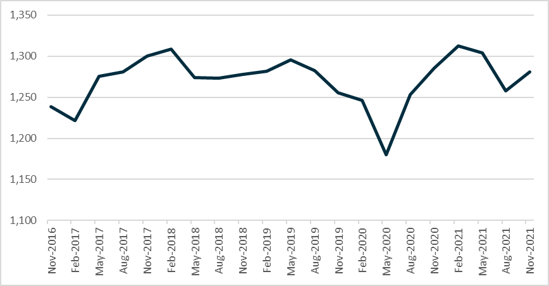

**Source***:* Australian Bureau of Statistics, Labour Force, Detailed, Quarterly*,* seasonally adjusted, November 2021.

Many retail businesses are pivoting to increase their digital service offer, seeking to benefit from the trend towards online retailing.[171] This will have flow-on effects to the skills that are sought after by retail businesses, including diversification of roles within traditional bricks-and-mortar stores, with demand for e-commerce related skills[172] potentially providing another career pathway from entry-level roles in the industry. This transition to online retailing also has implications for the supply chain, particularly workforce needs in the Transport, Postal and Warehousing industry.

Figure 22. Uneven sector growth is projected over the five years from November 2020 to November 2025 (‘000s)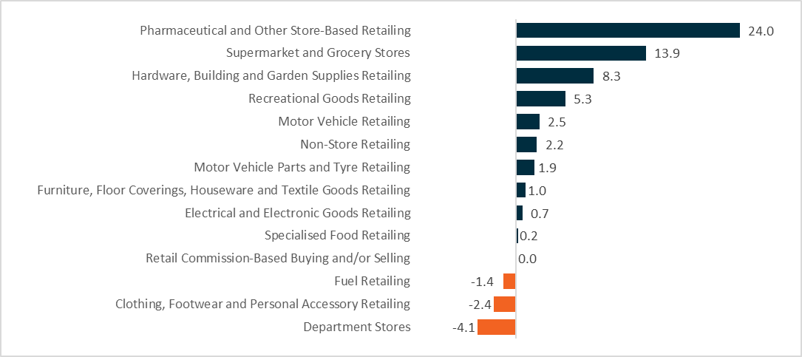Source: 2020 Industry Projections: Five years to November 2025*,* National Skills Commission, 2020.

## Opportunities for youth and part-time workers

Retail trade employs more young people than most other industries. Around 30 per cent of the retail workforce are aged 15 to 24 years, which is more than twice as many as the national average across all industries.[173]

Many occupations in the industry can provide flexible hours, allowing work around education, caring and other commitments. This is reflected in the numbers of casual and part-time workers in the industry. Around half (50.2 per cent) of Retail Trade workers are employed part-time.[174]

Some stakeholders flagged that the retail industry can be seasonal, with businesses hiring more staff in advance of peak periods, including Easter and Christmas holidays. This means job seekers may be more successful in obtaining employment at certain times of the year.

Over time, the proportion of mature age workers in the industry has gradually increased. In November 1991, 6.5 per cent of retail workers were aged 55 years and over. By November 2021, this had climbed to nearly 16.7 per cent, the highest proportion on record.[175]

Some stakeholders suggested that many people take up part-time and casual retail jobs while studying, but often leave the industry once they graduate. This is supported by ABS data that shows staff turnover is high in some large occupations in the Retail Trade industry. For example, sales assistants, checkout operators and office cashiers, and shelf fillers (three of the top four employing broader occupations in the Retail Trade industry) overall experience high turnover. [176]

Staff turnover can, in part, be linked to perceptions of lack of career progression and opportunities, particularly for staff in small businesses which make up a large proportion of the industry. Despite these perceptions there are many career pathways in the industry (from entry level to supervisory and management roles), supported by accredited training courses and other staff development.[177] Support to connect with career pathways in the industry can also provide sustainable long-term employment for job seekers interested in a career in Retail Trade.

## Retail provides an opportunity to gain skills and experience and explore career pathways

Traditionally the Retail Trade industry has provided opportunities for new labour market entrants who may not have qualifications or experience to gain valuable work experience and skills. Though these employability skills are transferable to many other industries and occupations[178], as outlined above there are also opportunities to connect with career pathways in the industry.

As part of the consultation process, stakeholders identified the increasing need for retail workers to develop digital literacy skills, in addition to soft skills such as communication skills, customer service, reliability, teamwork and complaint resolution.

Figure 23. More than half of all Retail Trade workers are Skill Level 5

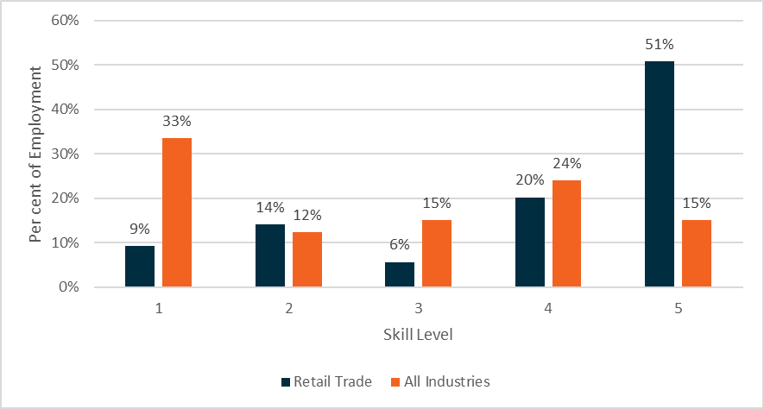

**Source**: Australian Bureau of Statistics, Labour Force Estimates, Customised Table - Employed Persons, by Industry Division of Main/Last Job, by Occupation of Main/Last Job, 2020, provided by the National Skills Commission.

There are opportunities to provide pre-employment training or work experience to ensure job seekers have core employability skills to take up roles in the sector including the confidence to undertake customer service and sales roles. Around half of retail workers are considered to be at a Skill Level 5 (equivalent to a Certificate I or secondary education) – see *Figure 23* (see *Figure 5* for skill level definitions). There are many vacancies for low-skilled or entry level roles, with sales assistants (general) the most advertised occupation across all industries.[179]

The retail industry is one of the industries that jobactive participants are most commonly placed. Since July 2015, over 215,000 job placements have been made into retail positions.[180] This indicates that many job seekers in the new model are likely to be suitable for taking up opportunities in the retail industry to gain valuable skills and experience.

**Key Points**

* The shift towards digitisation and online retailing has been accelerated by the COVID-19 pandemic influencing the skills workers need in the industry.
* The industry has a range of entry level roles that provide an opportunity for job seekers to gain valuable skills and work experience.
* Pre-employment training can provide job seekers with core employability skills.
* Roles may provide flexibility for those looking to combine work with study, caring responsibilities, and other commitments.
* Training and support to connect with career pathways may assist with retention.
* There is an opportunity to support greater workforce diversity and employment of job seekers, including for example mature age workers, people with disability and Aboriginal and Torres Strait Islander peoples.

# Transport, Postal and Warehousing

|  |
| --- |
| Industry snapshot The Transport, Postal and Warehousing industry includes services which supports the critical supply chain to connect people and goods by road, rail, sea or air. Examples include postal and courier services, warehousing, storage, freight and logistics management.  The industry employs around five per cent of Australian workers.[181] The highest employing occupations[182] in the industry are:   * Truck Drivers * Automobile Drivers * Storepersons * Bus and Coach Drivers * Couriers and Postal Deliverers.   More than three out of four jobs at Skill Levels 4 and 5[183], noting specific licences and tickets may be required to work in certain roles.  This industry is projected to grow by 47,300 workers, or 7.3 per cent, over the five years from November 2020 to November 2025.[184] |

## A resilient industry adapting to COVID-19 and e-commerce

Australia relies on national freight and global and local supply chains to stock supermarkets and retail stores with goods, ensure hospitals have essential equipment and pharmaceuticals, and transport construction materials and petrol to where they are needed.[185]

The COVID-19 pandemic significantly affected the Transport, Postal and Warehousing industry due to the changes to the movement of people and goods. COVID-19 has reinforced the need to maintain supply chains at a time when there is strong demand for goods and services, whilst dealing with boarder closures and lockdowns which has affected delivery and the operation of the industry.[186] This includes the movement, processing and storage of goods, in addition to the coordination of logistics to facilitate the progression through the supply chain.

Additionally, the increase in demand for online retailing and the associated acceleration of businesses moving online, has not only affected how the Retail Trade industry is doing business, but it has also increased demand for services across the Transport, Postal and Warehousing industry.[187]

The demand for postal services increased to meet the significant increase in parcel volumes, with over 9.1 million households shopping online in 2020–21.[188] Employment for Postal and Courier Pick-up and Delivery Services has grown 14,800 (15.2 per cent) since February 2020.[189] During consultation on the Framework, stakeholders also identified truck driving, forklift driving and ‘pick and pack’ services in warehousing and distribution as areas of significant demand.

## Demand for services will remain strong, supporting employment growth in the industry

The *National Freight and Supply Chain Strategy*[190] highlighted that freight volumes are projected to grow 35 per cent between 2018 and 2040[191], with an almost 60 per cent increase in urban freight over 20 years to 2040.[192] The industry strategy and associated national action plan and implementation plans[193] have been developed to outline government and industry action to support this growth, including the need of a skilled and adaptable workforce.

Employment across the Transport, Postal and Warehousing industry is projected to grow by 47,300 workers, or 7.3 per cent, over the five years from November 2020 to November 2025.[194]

Figure 24. Projected growth across the Transport, Postal and Warehousing industry

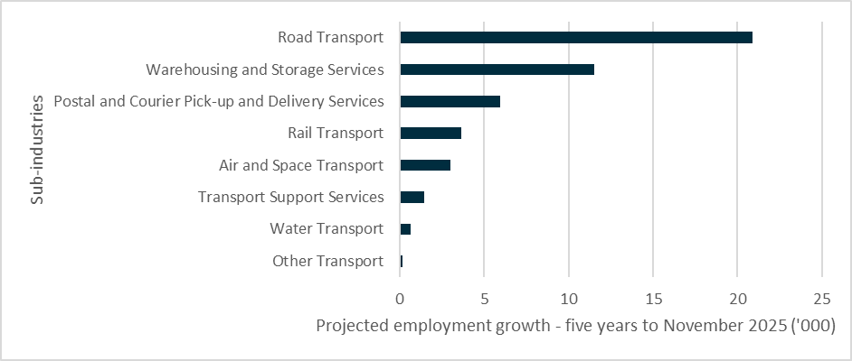**Source**: National Skills Commission, Industry employment projections, Five years to November 2025.

In addition to the jobs created by industry growth, around 26 per cent of Transport, Postal and Warehousing workers are aged 55 years and over (compared with the industry average of 20 per cent).[195] With more than one in four workers within ten years of retirement age there will be demand for new workers to enter the industry. In addition, addressing the underrepresentation of women in this industry is a priority, with multiple initiatives to increase women’s participation[196], which is currently around 22 per cent.[197] There are opportunities to support greater workforce diversity when assisting job seekers connect to jobs in Transport, Postal and Warehousing.

## There are a range of roles that provide opportunities for job seekers

Around three in four roles across the Transport, Postal and Warehousing industry have minimal entry requirements (Skill Levels 4 and 5[198] – see *Figure 25* and *Figure 5* for skill level definitions). This provides the opportunity for many job seekers to enter the industry, often with training and/or support to obtain relevant licences, certificates or tickets. For example, many roles may require a driver’s licence, truck/heavy vehicle licence, forklift licence, construction white card and/or ‘working at heights’ ticket.[199] This is demonstrated in the types of roles that are common across the industry as shown in *Figure 26*. There are also a range of support service roles across the supply chain such as storepersons, and roles to support transport and logistic operations that provide job seekers an opportunity to enter the industry.

Figure 25. Skill level of Transport, Postal and Warehousing industry workers

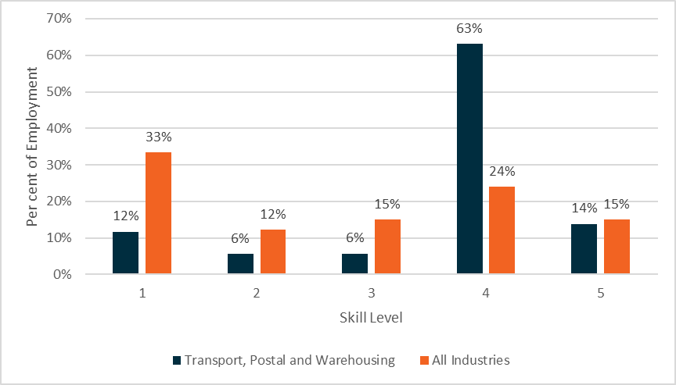

**Source**: Australian Bureau of Statistics, Labour Force Estimates, Customised Table - Employed Persons, by Industry Division of Main/Last Job, by Occupation of Main/Last Job, 2020, provided by the National Skills Commission.

Stakeholders also noted in some cases perceptions of the industry (particularly road freight transport[200]) may affect people’s willingness to consider employment in the industry. There is an opportunity to provide job seekers greater awareness of the roles and career pathways across the industry, as well as training and support to gain the necessary skills and experience.

Figure 26. Top occupations in the Transport, Postal and Warehousing industry (‘000s)

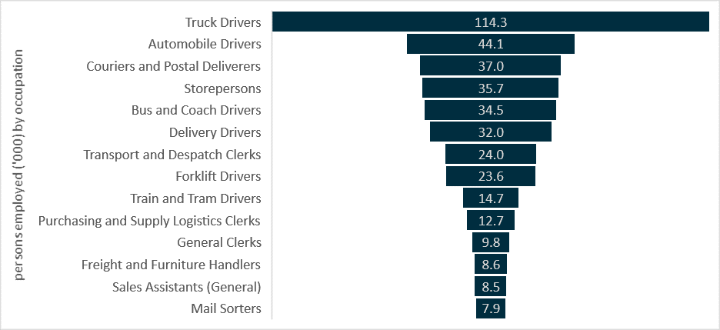

**Source**: ABS, Labour Force Estimates, Customised Table - Employed Persons, by Industry Division of Main/Last Job, by Occupation of Main/Last Job, 2020, provided by the National Skills Commission.

## Drivers are a key part of this industry

During stakeholder consultation for the Framework, Truck Drivers were identified across multiple industries as an occupation in demand that provides an opportunity for job seekers.

Over 2020, Truck Drivers were the largest employing occupation in the Transport, Postal and Warehousing industry at around 18 per cent of the industry’s workforce.[201] Truck Drivers are also employed across a range of other industries including Construction, Mining, and Electricity, Gas, Water and Waste Services. Across all industries, the projected employment growth for Truck Drivers is 6.5 per cent[202], with the occupation identified on the Skills Priority List 2021 as having projected strong future demand.[203]

The age profile for Truck Drivers is generally older, with an average age of 47 years compared to 40 years across all jobs.[204] The occupation is also male-dominated and only four per cent of workers are female.[205] There is an opportunity to promote greater workforce diversity by supporting a younger cohort of job seekers and female job seekers to take up roles within the industry, noting that insurance costs may be significantly higher for young people aged under 25 years[206].

The licencing and years of driving experience required for truck driving roles will depending on the type of heavy vehicle class.[207] Qualifications that could support employment in these roles, include Certificate II and III in Driving Operations. In 2022, a new truck driving apprenticeship (Certificate III in Driving Operations) will be developed in conjunction with industry as well as states and territories.[208] The new apprenticeship is strongly supported by industry with a need to create career pathways, ensure the safety of those on the road and in the industry, and attract new entrants.[209]

With support to obtain relevant licences and undertake training as well as gain the required driving experience and confidence required for heavy vehicles, this occupation may provide opportunities for job seekers across a range of industries.

## Digitisation and automation will continue to change the workforce needs of the sector

COVID-19 has accelerated changes to the way goods are purchased and distributed. Technological advances including digitisation and automation, will likely improve freight productivity[210] and also influence the skills people need to work in the industry.[211] For example, workers in warehouses and across the supply chain, as well as truck drivers are experiencing a greater level of digitisation and automation in their roles.[212]

Digitisation is leading to greater volumes of data being captured, which can be used in supply chain and logistics management to improve productivity and efficiency[213]. The increase in online retailing involves different customer service, transport and distribution logistics compared to in‑person purchases,[214] with customers expecting a fast and seamless purchasing and delivery experience.[215]

The skills in demand across the sector will continue to be influenced by these changes. The growing importance of supply chain and logistics management also provides a career pathway for job seekers and workers within the industry. These roles can require additional study, providing opportunities for workers to build on their core industry skills and experience to support career progression.[216]

**Key Points**

* The COVID-19 pandemic has significantly affected the Transport, Postal and Warehousing industry, with an increase in demand for some services and restrictions on the movement of goods and people.
* There are a range of entry level roles within the industry – job seekers may require support to gain relevant licences/certificates to take up these opportunities.
* Truck drivers is an in-demand occupation across the Transport, Postal and Warehousing industry and other industries – job seekers may require support to acquire the relevant licences, skills and driving experience/confidence.
* Digitisation and automation are changing the way goods are purchased and distributed – with implications for the skills in demand across the industry.
* There is an opportunity to support greater workforce diversity and employment of job seekers, including for example women, youth, people with disability and Aboriginal and Torres Strait Islander peoples.

# Emerging Priorities

Workforce Specialist projects will predominantly focus on industries identified in the *Workforce Connections: Workforce Specialist Project Framework*. Workforce Specialist projects may also be delivered to respond to emerging workforce opportunities or challenges not directly linked to one of the industries identified in this Framework. This flexible approach will generally occur in two circumstances, where there is:

1. an **immediate need** for support in response to a rapidly emerging labour market opportunity or challenge, or
2. an **emerging and significant labour market opportunity** for job seekers outside of the identified industries,

that the department determines would benefit from a Workforce Specialist project.

## Immediate needs

The labour market is dynamic and influenced by a range of external factors and events. COVID-19 has reinforced that rapid changes can occur to the labour market, and certain businesses, industries and parts of the country can be impacted to different degrees. A Workforce Specialist could play a part in the Government’s response to an immediate labour market or industry challenge, particularly where there are many opportunities for job seekers or job seekers are likely to be affected on a large scale.

Potential examples could include:

* a large-scale natural disaster such as a bushfire or flood, that affects a large area or multiple areas,
* a large-scale industry closure or significant structural adjustment (including due to widespread technological development or adoption).

Such a project would need to complement other programs and initiatives that form part of a response, which may include collaborating with various local stakeholders.

## Emerging and significant opportunities

The Framework identifies those industries with workforce needs that also have significant labour market opportunities for job seekers on a large scale.

There may be instances where an emerging labour market opportunity is identified in an industry not currently included in this Framework that is significant and would benefit from a Workforce Specialist project. It may be a time limited response or may be part of an emerging trend within the industry that would also be considered as part of the next scheduled review of the Framework.

Any emerging opportunity that is not connected to one of the identified industries in the Framework would need to represent a workforce need with significant opportunity for job seekers that cannot be met (or fully met) through other programs and supports or the ordinary functioning of the labour market. Any proposed project idea would also need to align with the objectives of the Workforce Specialists initiative and represent value for money.

Emerging opportunities may occur in industries that are currently transforming or growing as a result of significant investment, the acceleration of digitisation and automation, the emergence of new technologies and/or changing priorities during the COVID-19 recovery. Similarly, changes affecting industries or occupations may have an economic impact that creates opportunity, such as the progressive implementation of automatic mutual recognition of occupational registrations across states and territories. A Workforce Specialist project may provide a mechanism to raise awareness of new or changing roles within an industry and/or connect a range of initiatives to provide job seekers with a pathway to access these new or changing roles including relevant skills, training and support.

For example:

* There are a range of skilled roles across the defence industry that are required to support delivery of the Australian Government’s significant investment in defence capability, including shipbuilding programs, and the recently announced Sovereign Guided Weapons Enterprise[217].
* *Australia’s Long-Term Emissions Reduction Plan* notes that more than 100,000 new jobs could be created in Australia by 2050 in the new energy economy, including substantial job opportunities in low emissions technology in regional communities[218]. This may include a range of employment opportunities, including in the construction and manufacturing fields.
* The *Digital Economy Strategy* outlines a vision for Australia to be a leading digital economy and society by 2030.[219] COVID-19 accelerated the take up of digital technology, with a range of skilled and other support roles required in the digital and technology sector. Additionally, the majority of jobs increasingly require some level of digital skills and new and emerging technologies are also changing the skills the workforce needs across industries.[220]

## Other considerations and future inclusion in the Framework

Any immediate needs or emerging opportunities would need to be considered in the context of the Framework and value for money principles. A total of $12.5 million of funding is available each financial year under the Workforce Specialists initiative. It is anticipated that the majority of this funding will be directed towards projects targeting industries identified in this Framework.

While there is flexibility to fund projects in other industries with emerging priorities, the department will also consider whether other industries or occupations should be added to the Framework in the future. As outlined in *Reviewing the Workforce Connections: Workforce Specialist Project Framework*, the department will regularly review the Framework and update where appropriate.

**Key Points**

* Workforce Specialist projects may also respond to emerging priorities – including:
  + an immediate need to support the response to a rapidly emerging opportunity or challenge (e.g. a natural disaster or large-scale industry closure/structural adjustment)
  + an emerging and significant labour market opportunity for job seekers outside of identified industries.
* These projects would need to represent a workforce need that cannot be met (or fully met) through other programs or the ordinary functioning of the labour market.
* Any emerging priority project idea would need to align with the objectives of the Workforce Specialists initiative and represent value for money.

# Reviewing the Workforce Connections: Workforce Specialist Project Framework

The *Workforce Connections: Workforce Specialist Project Framework* will be reviewed regularly to ensure the Framework remains current and reflective of the labour market and the workforce needs of industry.

A review of the Framework is expected to be undertaken by the department at least once a year, and more frequently if required. The review may be broad ranging or minor depending on the significance of changes to labour market conditions and the emergence of workforce needs and identified strategies/plans since the last update.

The review of the Framework is anticipated to include consideration of:

* the data and information outlined in the Data sources and methodology
* Workforce Specialist project ideas and proposals that have been received and projects delivered over the preceding period
* Workforce Specialist project delivery and outcomes
* new and updated workforce strategies and initiatives, and
* emerging priorities and challenges within identified industries and across other industries.

Where appropriate, the review will be supported by stakeholder consultation.

Following the review, an updated Framework may be developed and published.

## Industry duration in the Framework

Following each review of the Framework, identified industries may change. Some industries will remain in the Framework for multiple years, continuing to be a focus for numerous Workforce Specialist projects. Other industries may have shorter duration in the Framework. This will depend on a range of factors including forecast jobs growth, the economic recovery from COVID-19, labour market challenges and opportunities, stakeholder feedback and government policy priorities.

Table 3. Indicative duration of each industry’s inclusion in the Framework

|  |  |
| --- | --- |
| **Identified industry** | **Indicative duration** |
| Accommodation and Food Services | Short term (1–2 years) |
| Agriculture, Forestry and Fishing | Short term (1–2 years) |
| Construction | Medium term (2–3 years) |
| Health Care and Social Assistance | Long term (3–5 years) |
| Manufacturing | Medium term (2–3 years) |
| Retail Trade | Medium term (2–3 years) |
| Transport, Postal and Warehousing | Medium term (2–3 years) |

Each industry in the Framework will be subject to a minor review and update each time the Framework is reviewed. Additionally, the above table (*Table 3*) provides an indication of the length of time the industry will be in the Framework before a more substantial review. The indicative timing outlined above reflects a current consideration of the multiple factors considered when developing this Framework. The timing above is an estimate only and is in no way binding. Following review, an industry may remain in the Framework with minor updates, may remain in the Framework with a more significant change in focus, or may be removed from the Framework. Other industries may also be added during these reviews.

Any changes to the Framework will continue to focus on identifying those industries with workforce needs that also have significant labour market opportunities for job seekers.

**Key Points**

* The Workforce Connections: Workforce Specialists Project Framework will be reviewed annually, with consideration to relevant data analysis, evidence and stakeholder consultation.
* Industries will be subject to a minor review each year, with a significant review occurring as indicated in this Framework, unless otherwise required.
* Industries may be added or removed as part of the review process, or the focus and analysis updated. This will be based on updated data analysis and consultation in relation to the industry’s workforce needs, availability of labour market opportunities for job seekers and the capacity to benefit from a Workforce Specialist project.

# Appendix A

Figure 27. Employment level (‘000), November 2021

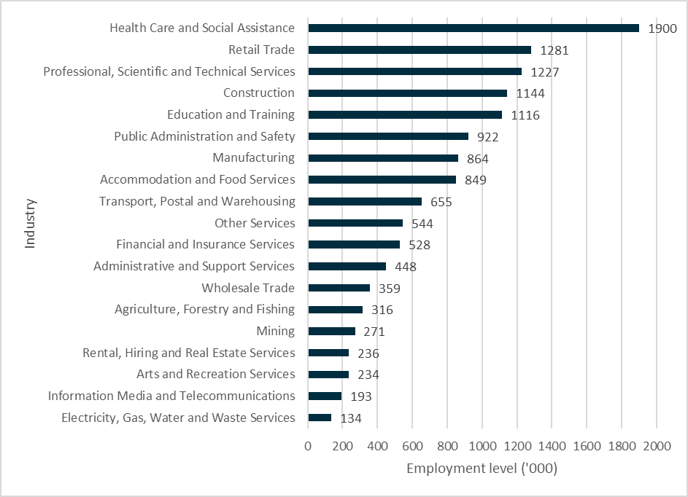

**Source:** Australian Bureau of Statistics, Labour Force, Detailed, Quarterly, seasonally adjusted, November 2021.

Figure 28. Projected employment growth (%) November 2020 to November 2025

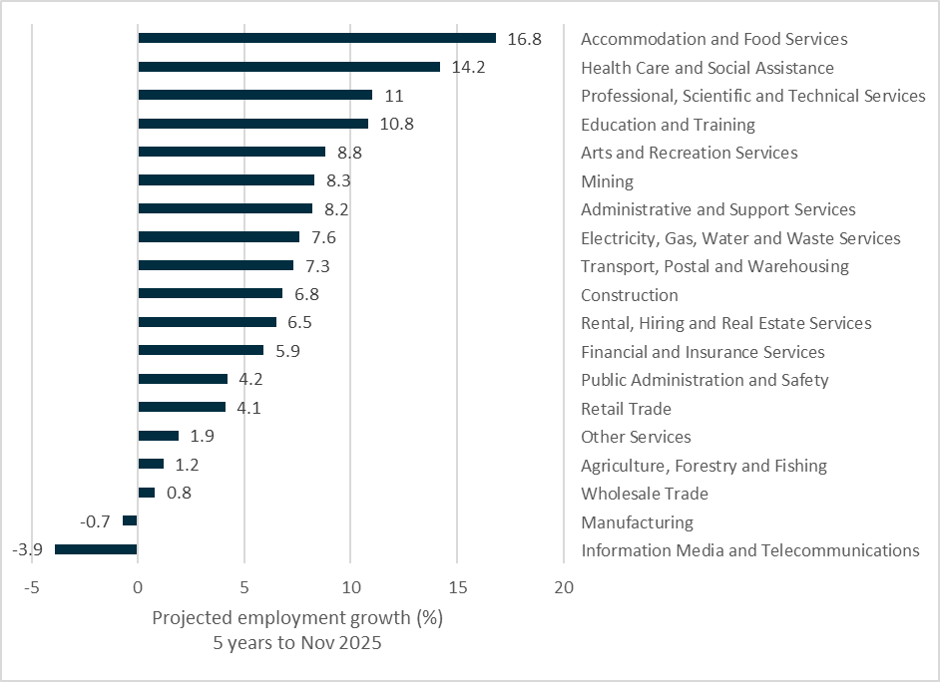

**Source:** National Skills Commission, Industry employment projections, Five years to November 2025.

1. National Skills Commission, Employment Outlook to November 2025, 2021.
2. Australian Government, *National Agreement on Closing the Gap*, July 2020
3. [www.dss.gov.au/disability-and-carers/disability-employment-strategy](http://www.dss.gov.au/disability-and-carers/disability-employment-strategy)
4. Further information about the Employment Services Advisory Group is available at [www.dese.gov.au/new-employment-services-model/employment-services-advisory-group](https://www.dese.gov.au/new-employment-services-model/employment-services-advisory-group)
5. See [www.dese.gov.au/new-employment-services-model/workforce-specialists/development-workforce-connections-plan](https://www.dese.gov.au/new-employment-services-model/workforce-specialists/development-workforce-connections-plan)
6. Australian Bureau of Statistics, Labour Force, Australia*,* December 2021, seasonally adjusted data.
7. Australian Bureau of Statistics, Labour Force, Australia, December 2021, seasonally adjusted.
8. ibid.
9. Department of Education, Skills and Employment, jobactive administrative data (including those in the New Employment Services Trial), December 2021.
10. National Skills Commission, Vacancy Report, December 2021, seasonally adjusted.
11. Ibid.
12. Reserve Bank of Australia, Statement on Monetary Policy, August 2021.
13. The Treasury, 2021 Intergenerational Report, June 2021.
14. ibid.
15. Australian Bureau of Statistics, Labour Force, Detailed, Quarterly, National Skills Commission, seasonally adjusted, November 2021.
16. Australian Bureau of Statistics, Labour Force, Detailed, Quarterly, National Skills Commission, seasonally adjusted, November 2021.
17. <https://humanrights.gov.au/our-work/employers/toolkits-guidelines-and-other-resources>
18. National Skills Commission, Employment Outlook to November 2025, 2021.
19. National Skills Commission, Employment Outlook to November 2025, 2021.
20. Australian Bureau of Statistics, Labour Force, Detailed, Quarterly, seasonally adjusted, November 2021.
21. National Skills Commission, 2020 Industry Projections: Five years to 2025.
22. Australian Bureau of Statistics, Labour Force, Detailed, Quarterly, National Skills Commission, seasonally adjusted, November 2021.
23. Australian Bureau of Statistics, Labour Force Estimates, Customised Table - Employed Persons, by Industry Division of Main/Last Job, by Occupation of Main/Last Job, 2020, provided by the National Skills Commission.
24. National Skills Commission, *Recruitment Insights Report*, October 2021.
25. National Skills Commission, Internet Vacancy Index, December 2021, seasonally adjusted.
26. National Skills Commission, Skills Priority List, 2021.
27. Australian Bureau of Statistics, Labour Force, Detailed, Quarterly, seasonally adjusted, November 2021.
28. National Skills Commission, *Australian Jobs Report 2021*.
29. National Skills Commission, *Employment Outlook to November 2025*, 2021.
30. Australian Bureau of Statistics, Labour Force, Detailed, Quarterly, National Skills Commission, seasonally adjusted, November 2021.
31. Department of Education, Skills and Employment, jobactive administrative data (excluding the ‘Other Services’ industry), 31 December 2021.
32. Australian Bureau of Statistics, Labour Force, Detailed, Quarterly, seasonally adjusted, November 2021.
33. National Skills Commission, Internet Vacancy Report, December 2021, seasonally adjusted.
34. National Skills Commission, *Employment Outlook to November 2025*, 2021.
35. Tourism Research Australia, *International Visitor Survey*, September quarter 2021.
36. Tourism Research Australia, *National Visitor Survey*, September quarter 2021.
37. ibid.
38. AusTrade, *Reimagining the Visitor Economy – Discussion Paper*, May 2021.
39. ibid.
40. National Skills Commission, *Recruitment Insights Report*, December 2021.
41. Australian Bureau of Statistics, Labour Force, Detailed, Quarterly, National Skills Commission, seasonally adjusted, November 2021.
42. ibid.
43. Australian Bureau of Statistics, Labour Force, Detailed, Quarterly, original data, November 2021.
44. Department of Education, Skills and Employment, jobactive administrative data, 31 December 2021.
45. Australian Bureau of Statistics, Labour Force, Detailed, Quarterly, seasonally adjusted, November 2021.
46. Australian Bureau of Statistics, Labour Force, Detailed, Quarterly, National Skills Commission, seasonally adjusted, November 2021.
47. National Skills Commission, *Australian Jobs Report 2021.*
48. Australian Government Department of Agriculture, Water and the Environment, Agricultural forecasts and outlook, December quarter 2021.
49. <https://www.agriculture.gov.au/sites/default/files/documents/ag-2030.pdf>
50. Australian Government Department of Agriculture, Water and the Environment, Delivering Ag2030, May 2021.
51. Australian Government Department of Agriculture, Water and the Environment, Snapshot of Australian Agriculture 2021, ABARES insights, Issue 2, 2021.
52. Australian Government Department of Agriculture, Water and the Environment, Snapshot of Australian Agriculture 2021, ABARES insights, Issue 2, 2021.
53. ABARES, 2021, Labour use in Australian agriculture: Analysis of survey results, ABARES, Canberra, November, CC BY 4.0.
54. Australian Bureau of Statistics, Labour Force, Detailed, Quarterly, National Skills Commission, seasonally adjusted, November 2021.
55. National Skills Commission, Employment Outlook to November 2025, 2021.
56. Australian Government Department of Agriculture, Water and the Environment, Snapshot of Australian Agriculture 2021, ABARES insights, Issue 2, 2021.
57. Australian Bureau of Statistics, Labour Force, Detailed, Quarterly, National Skills Commission, seasonally adjusted, November 2021.
58. Australian Government Department of Agriculture, Water and the Environment, Delivering Ag2030, May 2021.
59. <https://www.abs.gov.au/statistics/classifications/anzsco-australian-and-new-zealand-standard-classification-occupations/latest-release>
60. <https://www.awe.gov.au/about/reporting/obligations/government-responses/building-the-agricultural-workforce-of-the-future>
61. <https://www.agriculture.gov.au/sites/default/files/documents/naws-roadmap.pdf>
62. <https://www.agriculture.gov.au/ag-farm-food/agricultural-workforce/naws>
63. <https://www.agriculture.gov.au/sites/default/files/documents/ag-2030.pdf>
64. <https://www.awe.gov.au/agriculture-land/farm-food-drought/innovation/national-ag-innovation-agenda>
65. Department of Agriculture, Water and Environment, Australia Government roadmap to attract, retain, upskill and modernise the agricultural workforce, March 2021.
66. Australian Government Department of Agriculture, Water and the Environment, Delivering Ag2030, May 2021.
67. <https://www.dese.gov.au/harvest-trail/agmove>
68. <https://www.awe.gov.au/sites/default/files/documents/naws-roadmap.pdf> and <https://www.awe.gov.au/agriculture-land/farm-food-drought/agricultural-workforce>
69. <https://www.palm.gov.au>
70. <https://www.dfat.gov.au/people-people/international-labour-mobility/australian-agriculture-visa>
71. <https://www.awe.gov.au/agriculture-land/farm-food-drought/agricultural-workforce>
72.
73. Department of Agriculture, Water and Environment, Australia Government roadmap to attract, retain, upskill and modernise the agricultural workforce, March 2021.
74. Australian Bureau of Statistics, Labour Force Estimates, Customised Table - Employed Persons, by Industry Division of Main/Last Job, by Occupation of Main/Last Job, 2020, provided by the National Skills Commission.
75. Australian Government Department of Agriculture, Water and the Environment, Delivering Ag2030, May 2021.
76. Australian Bureau of Statistics, Labour Force, Detailed, Quarterly, seasonally adjusted, November 2021.
77. National Skills Commission, *Australian Jobs Report 2021.*
78. National Skills Commission, *Employment Outlook to November 2025*, 2020.
79. Australian Bureau of Statistics, Labour Force, Detailed, Quarterly, National Skills Commission, seasonally adjusted, November 2021.
80. ibid.
81. National Skills Commission, *Australian Jobs Report 2021*.
82. Department of Education, Skills and Employment, jobactive administrative data, 31 December 2021.
83. Australian Bureau of Statistics, Labour Force, Detailed, seasonally adjusted, November 2021.
84. National Skills Commission, Vacancy Report, December 2021.
85. National Skills Commission, Vacancy Report, December 2021.
86. National Skills Commission, *Skills Priority List*, June 2021.
87. Infrastructure Australia, Market Capacity Report, October 2021.
88. ibid.
89. Australian Government, Department of Industry, Science, Energy and Resources, Australia’s Long-Term Emissions Reduction Plan, October 2021.
90. National Skills Commission, 2020 *Employment Projections – for the five years to November 2025,*2021
91. ibid.
92. Australian Bureau of Statistics, Labour Force, Detailed, Quarterly, National Skills Commission, seasonally adjusted, November 2021.
93. National Careers Institute, see: [yourcareer.gov.au/industries/E/construction](https://yourcareer.gov.au/industries/E/construction)
94. National Skills Commission, *Australian Jobs Report 2021*.
95. Australian Bureau of Statistics, Labour Force, Detailed, Quarterly, National Skills Commission, seasonally adjusted, November 2021.
96. Department of Education, Skills and Employment, jobactive administrative data, 31 December 2021.
97. The Boosting Apprenticeship Commencements wage subsidy reimburses 50 per cent of the wages eligible employers pay to a new or recommencing Australian Apprenticeship for a 12-month period from the date of commencement, to a maximum of $7000 per quarter. After 12 months of the BAC, employers can transition to the time-limited Completing Apprenticeship Commencements (CAC) wage subsidy. Under the CAC, eligible employers will receive a 10 per cent wage subsidy in the second year of an eligible apprenticeship (up to $1500 per quarter, per apprentice) and five per cent in the third year (up to $750 per quarter, per apprentice). For more information see: www.[dese.gov.au/boosting-apprenticeship-commencements](https://www.dese.gov.au/boosting-apprenticeship-commencements)
98. An Australian Government program run by Master Builders Australia (see: [womenbuildingaustralia.com.au](https://www.womenbuildingaustralia.com.au))
99. A Victorian Government program funded by the Apprenticeship Innovation Fund (see: [apprenticeships.vic.gov.au/apprentices-and-trainees/women-in-apprenticeships](http://www.apprenticeships.vic.gov.au/apprentices-and-trainees/women-in-apprenticeships))
100. <https://www.dese.gov.au/launch-work>
101. An Australian Government program supporting employers to attract and retain women returning to work after a career break (see: [dese.gov.au/employing-and-supporting-women-your-organisation/career-revive](https://www.dese.gov.au/employing-and-supporting-women-your-organisation/career-revive))
102. Australian Government, A Roadmap for Respect: Preventing and Addressing Sexual Harassment in Australian Workplaces, 2021.
103. National Centre for Vocational Education Research, DataBuilder, accessed 8 October 2021.
104. For example, the Australian Apprenticeship Support Network (see: [australianapprenticeships.gov.au](https://www.australianapprenticeships.gov.au)) and the Boosting Apprenticeship Commencements and Completing Apprenticeship Commencements wage subsidies (see: [www.dese.gov.au/boosting-apprenticeship-commencements](http://www.dese.gov.au/boosting-apprenticeship-commencements)).
105. National Centre for Vocational Education Research, DataBuilder, accessed 8 October 2021.
106. Department of Education, Skills and Employment, jobactive administrative data, 31 December 2021.
107. Australian Bureau of Statistics, Labour Force, Detailed, Quarterly, seasonally adjusted, November 2021.
108. National Skills Commission, *Australian Jobs Report 2021.*
109. Australian Bureau of Statistics, Labour Force, Detailed, Quarterly, National Skills Commission, seasonally adjusted, November 2021.
110. Relevant ANZSCO occupation titles: Aged and disabled carers and Nursing support and personal care workers.
111. 26 week-outcome conversion rate, jobactive administrative data for July 2015 - October 2021.
112. Australian Bureau of Statistics, Labour Force, Detailed, Quarterly, seasonally adjusted, November 2021.
113. National Skills Commission, *Employment Outlook to November 2025,* 2021.
114. ibid.
115. Commonwealth of Australia (Department of Social Services), NDIS National Workforce Plan: 2021–2025, 2021.
116. National Skills Commission, *Employment Outlook to November 2025,* 2021.
117. <https://www.health.gov.au/resources/publications/a-matter-of-care-australias-aged-care-workforce-strategy>
118. <https://www.dss.gov.au/disability-and-carers-publications-articles/ndis-national-workforce-plan-2021-2025>
119. <https://www.acecqa.gov.au/national-workforce-strategy>
120. Australian Bureau of Statistics, Labour Force, Detailed, Quarterly, seasonally adjusted, November 2021.
121. Australian Bureau of Statistics, Labour Force, Detailed, Quarterly, National Skills Commission, seasonally adjusted, November 2021.
122. ibid.
123. Commonwealth of Australia (Department of Social Services), *NDIS National Workforce Plan: 2021–2025*, 2021.
124. Relevant ANZSCO occupation titles: Aged and disabled carers and Nursing support and personal care workers.
125. Aged Care Workforce Strategy Taskforce, *A Matter of Care Australia’s Aged Care Workforce Strategy*, June 2018
126. Australian Bureau of Statistics, Labour Force Estimates, Customised Table - Employed Persons, by Industry Division of Main/Last Job, by Occupation of Main/Last Job, 2020, provided by the National Skills Commission
127. National Skills Commission, 2020 *Employment Projections – for the five years to November 2025,*2021.
128. Commonwealth of Australia (Department of Social Services), *NDIS National Workforce Plan: 2021–2025*, 2021.
129. Australian Government Department of Health, *2020 Aged Care Workforce Census Report*, 2021.
130. Commonwealth of Australia (Department of Social Services), *NDIS National Workforce Plan: 2021–2025*, 2021.
131. ibid.
132. <https://www.dese.gov.au/jobs-hub/care/explore-care-careers#good-fit>
133. Commonwealth of Australia (Department of Social Services), NDIS National Workforce Plan: 2021–2025, 2021.
134. <https://www.health.gov.au/sites/default/files/documents/2021/05/workforce-pillar-4-of-the-royal-commission-response-growing-a-skilled-and-high-quality-workforce-to-care-for-senior-australians.pdf>
135. Commonwealth of Australia (Department of Social Services), *NDIS National Workforce Plan: 2021–2025*, 2021.
136. <https://www.dese.gov.au/about-us/corporate-reporting/budget/budget-202122#toc-skills-and-training>
137. Australian Government Department of Health, *2020 Aged Care Workforce Census Report*, 2021.
138. Australian Bureau of Statistics and Statistics New Zealand, Australian and New Zealand Standard Industrial Classification (ANZSIC), 2006.
139. Australian Bureau of Statistics, Labour Force, Detailed, Quarterly, National Skills Commission, seasonally adjusted, November 2021.
140. National Skills Commission, 2020 *Employment Projections – for the five years to November 2025,*2021.
141. Australian Government, National Skills Commission, Skills Priority List, June 2021.
142. <https://www.acecqa.gov.au/qualifications/qualification-requirements>
143. Australian Bureau of Statistics, Labour Force Estimates, Customised Table - Employed Persons, by Industry Division of Main/Last Job, by Occupation of Main/Last Job, 2020, provided by the National Skills Commission.
144. ibid.
145. Australian Bureau of Statistics, Labour Force, Detailed, Quarterly, seasonally adjusted, November 2021.
146. National Skills Commission, *Australian Jobs Report 2021.*
147. Australian Bureau of Statistics, Labour Force Estimates, Customised Table - Employed Persons, by Industry Division of Main/Last Job, by Occupation of Main/Last Job, 2020, provided by the National Skills Commission.
148. National Skills Commission, *Australian Jobs Report 2021.*
149. Department of Education, Skills and Employment, jobactive administrative data (excluding the ‘Other Services’ industry), 31 December 2021.
150. Australian Bureau of Statistics and Statistics New Zealand, Australian and New Zealand Standard Industrial Classification, 2006.
151. Australian Bureau of Statistics, ‘Australian National Accounts: Input-Output Tables’ Table 8, catalogue number 5209.0.55.001, 2018–19.
152. National Skills Commission, *Australian Jobs Report 2021.*
153. GVA is the gross value of output minus consumption costs. For example, a food product manufacturer makes $1 million in a year, but it costs $800,000 of ingredients to make the products they sell. Their GVA is therefore $200,000.
154. Australian Bureau of Statistics, ‘Australian System of National Accounts’, catalogue number 5204.0, June 2021.
155. Office of the Chief Economist calculations using ABS Cat. 8155 – Australian Industry, 2018–19, Manufacturing Industry
156. Department of Industry, Science, Energy and Resources, [Make it Happen: the Australian Government’s Modern Manufacturing Strategy](https://www.industry.gov.au/data-and-publications/make-it-happen-the-australian-governments-modern-manufacturing-strategy), October 2020.
157. Australian Bureau of Statistics, Labour Force, Detailed, Quarterly, seasonally adjusted, November 2021
158. Department of Industry, Science, Energy and Resources, [Make it Happen: the Australian Government’s Modern Manufacturing Strategy](https://www.industry.gov.au/data-and-publications/make-it-happen-the-australian-governments-modern-manufacturing-strategy), October 2020.
159. Australian Bureau of Statistics, Labour Force, Detailed, Quarterly, National Skills Commission, seasonally adjusted, November 2021.
160. Australian Bureau of Statistics, Labour Force, Detailed, Quarterly, National Skills Commission, seasonally adjusted, November 2021.
161. Australian Government Department of Industry, Science, Energy and Research, Make it Happen: The Australian Government’s Modern Manufacturing Strategy, October 2020.
162. IBSA Group, Scaling Up – Delivering Modern Manufacturing through a Skilled Workforce, 2021.
163. National Skills Commission, Industry employment projections, Five years to November 2025.
164. Australian Government Department of Industry, Science, Energy and Resources, Australia’s whole-of-economy long term emissions reduction plan, 2021.
165. Australian Bureau of Statistics, Labour Force, Detailed, Quarterly, seasonally adjusted, November 2021.
166. National Skills Commission, *Australian Jobs Report 2021*.
167. Australian Bureau of Statistics, Labour Force, Detailed, Quarterly, National Skills Commission, seasonally adjusted, November 2021.
168. Australian Bureau of Statistics, Labour Force, Detailed, Quarterly, seasonally adjusted, November 2021.
169. National Skills Commission, *Employment Outlook to November 2025*, 2021.
170. Australian Bureau of Statistics, *Retail Trade*, Australia, seasonally adjusted, November 2021.
171. Inside Retail & KPMG, *Australian Retail Outlook 2021*, Australia, <https://home.kpmg/content/dam/kpmg/au/pdf/2021/australian-retail-outlook-2021-report.pdf>
172. SEEK, *Retail industry braces for e-commerce challenge*,[seek.com.au/employer/market-insights/industry-spotlight-on-retail-and-consumer-products](http://www.seek.com.au/employer/market-insights/industry-spotlight-on-retail-and-consumer-products), accessed 29 October 2021.
173. Australian Bureau of Statistics, Labour Force, Detailed, Quarterly, National Skills Commission, seasonally adjusted, November 2021.
174. ibid.
175. ibid.
176. National Skills Commission, *Employment Conditions and Outlook for Retail Trade*, 2020.
177. Wholesale and Retail Industry Reference Committee, *Industry Skills Forecast 2019*, SkillsIQ Limited, Sydney, <https://www.skillsiq.com.au/site/DefaultSite/filesystem/documents/Industry-Skills-Forecasts-June2017/2019%20Final%20ISFs/2019%20Industry%20Skills%20Forecast%20Wholesale%20and%20Retail%20IRC%20Web.pdf>
178. National Skills Commission, *Employment Conditions and Outlook for Retail Trade*, 2020.
179. National Skills Commission, *Internet Vacancy Index – Detailed Occupation Data*, November 2021.
180. Department of Education, Skills and Employment, jobactive administrative data, 31 December 2021.
181. Australian Bureau of Statistics, Labour Force, Detailed, Quarterly, seasonally adjusted, November 2021.
182. National Skills Commission, *Australian Jobs Report 2021*.
183. ABS, Labour Force Estimates, Customised Table - Employed Persons, by Industry Division of Main/Last Job, by Occupation of Main/Last Job, 2020, provided by the National Skills Commission.
184. National Skills Commission, *Employment Outlook to November 2025*, 2021.
185. Transport and Infrastructure Council, National Freight and Supply Chain Strategy 2019.
186. Australian Industry Standards, Industry Outlook 2021 Transport and Logistics, Industry Reference Committee, 2021.
187. ibid.
188. Australia Post, Annual Report 2021.
189. Australian Bureau of Statistics, Labour Force, Detailed, Quarterly, National Skills Commission, seasonally adjusted, November 2021.
190. Transport and Infrastructure Council, National Freight and Supply Chain Strategy 2019.
191. ibid.
192. ibid.
193. [freightaustralia.gov.au/what-are-we-doing/implementation-plans](https://www.freightaustralia.gov.au/what-are-we-doing/implementation-plans)
194. National Skills Commission, Employment Outlook to November 2025, 2021.
195. Australian Bureau of Statistics, Labour Force, Detailed, Quarterly, National Skills Commission, seasonally adjusted, November 2021.
196. Centre for Supply Chain and Logistics, Wayfinder: Supply chain careers for women initiative; Victorian Government Women in Transport Strategy 2021–24; Transport for NSW women’s career initiative.
197. Australian Bureau of Statistics, Labour Force, Detailed, Quarterly, National Skills Commission, seasonally adjusted, November 2021.
198. ABS, Labour Force Estimates, Customised Table - Employed Persons, by Industry Division of Main/Last Job, by Occupation of Main/Last Job, 2020, provided by the National Skills Commission.
199. National Skills Commission, *Australian Jobs Report 2021.*
200. The Senate, Rural and Regional Affairs and Transport References Committee, Without Trucks Australia Stops: the development of a viable, safe, sustainable and efficient road transport industry, August 2021.
201. ABS, Labour Force Estimates, Customised Table - Employed Persons, by Industry Division of Main/Last Job, by Occupation of Main/Last Job, 2020.
202. National Skills Commission, 2020 *Employment Projections – for the five years to November 2025,*2021.
203. National Skills Commission, Skills Priority List 2021.
204. Job Outlook Truck Drivers, [joboutlook.gov.au/occupations/truck-drivers?occupationCode=7331](https://joboutlook.gov.au/occupations/truck-drivers?occupationCode=7331), accessed 14 October 2021
205. Australian Bureau of Statistics, Labour Force, Detailed, Quarterly, National Skills Commission, seasonally adjusted, November 2021.
206. The Senate, Rural and Regional Affairs and Transport References Committee, Without Trucks Australia Stops: the development of a viable, safe, sustainable and efficient road transport industry, August 2021.
207. For example: <https://roads-waterways.transport.nsw.gov.au/business-industry/heavy-vehicles/licence/index.html>
208. <https://ministers.dese.gov.au/robert/new-trucking-apprenticeship-keep-driving-australias-economy>, 20 December 2021.
209. <https://www.australianindustrystandards.org.au/heavy-vehicle-driver-apprenticeship/>
210. Transport and Infrastructure Council, National Freight and Supply Chain Strategy 2019.
211. Australian Industry Standards, Industry Outlook 2021 Transport and Logistics, Industry Reference Committee, 2021.
212. ibid.
213. Deloitte Access Economics, The future of work – Occupational and education trends in supply chain and logistics in Australia, January 2018.
214. ibid.
215. Australian Industry Standards, Skills Forecast Annual Update 2020 Transport and Logistics, Industry Reference Committee, 2020.
216. ibid.
217. <https://www.defence.gov.au/project/sovereign-guided-weapons-and-explosive-ordnance-enterprise>
218. Australian Government, Department of Industry, Science, Energy and Resources, Australia’s Long-Term Emissions Reduction Plan, October 2021.
219. Commonwealth of Australia, Department of the Prime Minister and Cabinet, Digital Economy Strategy 2030, 2021.
220. ibid.